(2024-2025)
Society Name: Enactus Hansraj
Convener: Ms. Alka Kacker
Core: Milap Bansal (President), Yukti Goel (Vice President), Shatakshi Singh (Vice President), Shivani Kundu (General Secretary), Pushpinder Singh (Joint Secretary), Arunav Sharma (Joint Secretary).

Enactus Hansraj - Annual Report 2024-25
At Enactus Hansraj, we continue to foster social entrepreneurship and create a sustainable
impact. In 2024-25, we achieved significant milestones across our projects, advanced
innovation, and expanded community engagement. Our participation in Enactus Nationals 2024
placed us among the top 19 teams in India.
Project Ahsaas launched the “Diksha” vertical—an online platform empowering the specially
abled for government exams, collaborating with 15+ NGOs like National Association for the
Blind, Yes We Can Trust, Ujjala Society, Deep Blind Welfare Association, Shristi Parents
Support Group, and The Blind Relief Association. Project Mehr explored natural dyeing
techniques to address floral pollution, partnered with Gulmeher NGO, and developed new
products like potpourri and naturally dyed fabrics.
We are aiming to introduce Project Nirmal, focusing on reducing algae growth in the Yamuna
River and producing eco-friendly cleaners while supporting acid attack survivors. Our research
advanced bioplastic production using red algae and bio-enzyme cleaners from natural
ingredients.
Our community-driven efforts extended through eight impactful drives in collaboration with
Bharat Sewa Kendra, Quality Elder Homes, Global Roti Walk, Saksham Kids NGO, Prerna NGO
(AIDS Day), NAB Drive, Energy Conservation Drive, and Dogs Feeding Drive. These initiatives
helped uplift marginalized communities and promote sustainable living.
Our Research & Development initiatives focused on sustainability and innovation. We explored
converting coffee grounds into cutlery, utilizing stubble and agricultural waste for paper and
green boards, producing bioplastic from algae, transforming coconut husks into décor, and
developing bio-enzymes from citrus peels.
Events like Mitti Mela and Mitticulous fostered inclusivity and collaboration, featuring guest
speakers and Enactus chapters nationwide. We strengthened our outreach through social
media and participation through stalls at platforms like IIT Delhi and GMR Aerocity Mall.
Recognized by the Ministry of Skill Development & Entrepreneurship and major media outlets,
we remain committed to driving sustainable change and empowering communities.

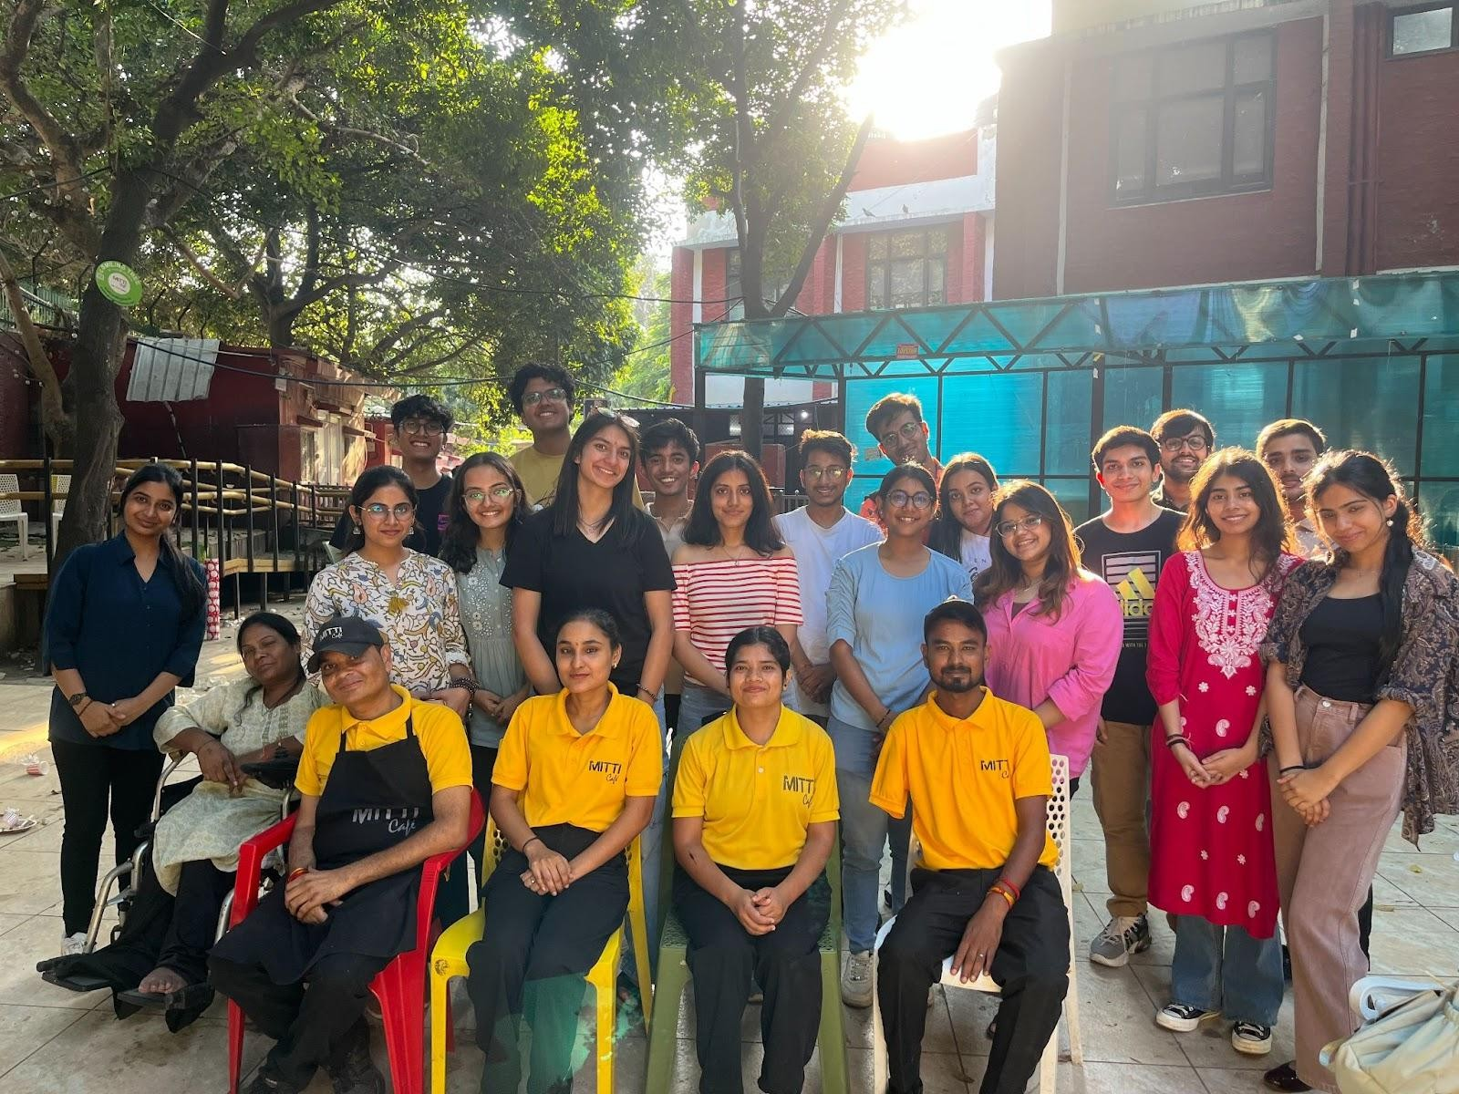
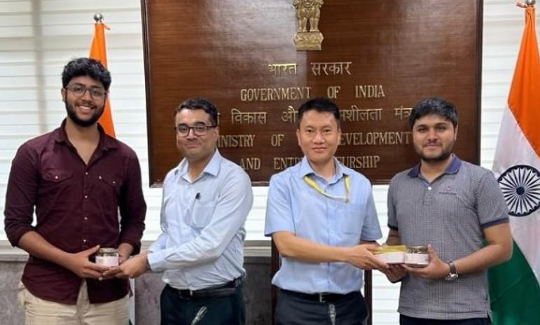
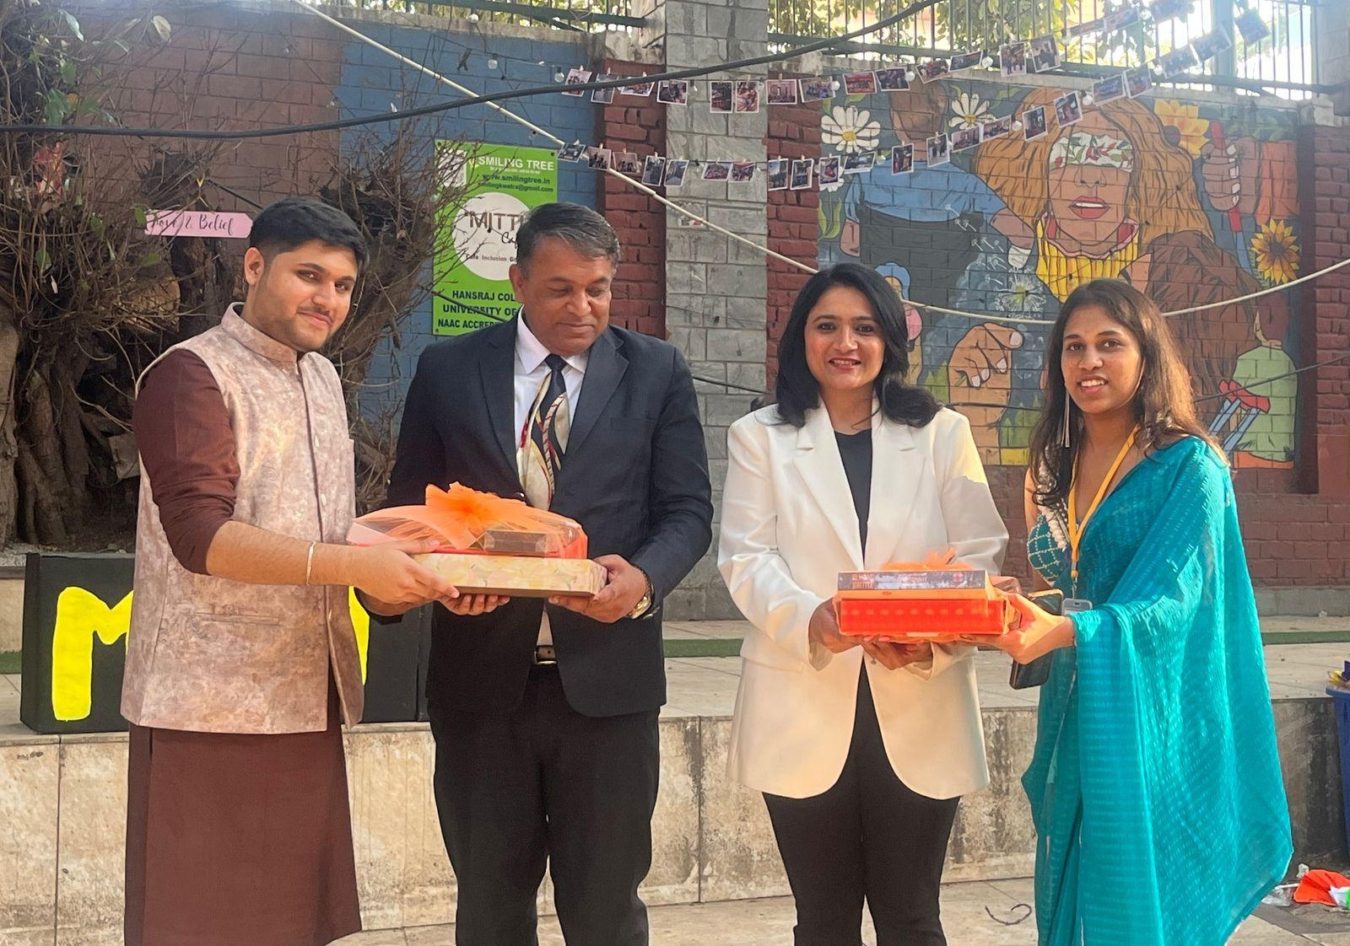
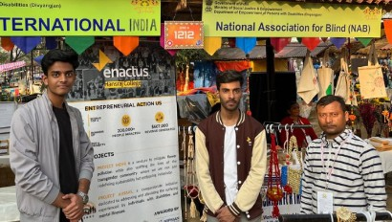
Some Glimpses:
