Features of Kangra painting[edit]
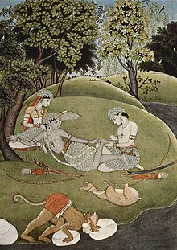
Rama and Sita in the forest, 1780
One striking feature of Kangra paintings is the verdant greenery it depicts. The style is naturalistic, and great attention is paid to detail. The foliage depicted is vast and varied. This is made noticeable by using multiple shades of green. The Kangra paintings feature flowering plants and creepers, leafless trees, rivulets and brooks.
The Kangra artists adopted various shades of the primary colors and used delicate and fresher hues. For instance, they used a light pink on the upper hills to indicate distance.
Kangra paintings depict the feminine charm in a very graceful manner. Facial features are soft and refined. The female figures are exceptionally beautiful.

Later Kangra paintings also depicted nocturnal scenes, and storms and lightning. The paintings were often large and had complex compositions of many figures and elaborate landscapes. Towns and house clusters were often depicted in the distance.
The Kangra painters used colors made of vegetable and mineral extracts. They employed cool and fresh colors. Kangra paintings are known for the lyrical blending of form and color.

