B. Sc. (P) Physical Sciences IV Sem. (2019-20)
Paper : Waves and Optics; UPC : 42224412
Wave Motion - Wave motion is the transfer of energy and momentum from one point of the medium to another point of the medium without actual transport of matter between two points.
OR
It is a form of disturbance in a medium and is due to repeated periodic movements of the particles of the medium about their mean positions, the disturbance being handed on from one particle to the next in a definite phase relationship.
Wave motion is classified into three different ways,
- The medium of propagation,
- The dimensions in which a wave propagates energy,
- The energy transfer
Classification of Wave Motion

Based on the Medium of Propagation
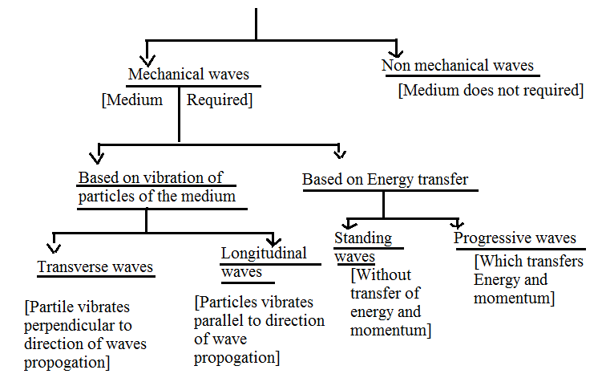

Number of Dimensions a Wave Propagates Energy
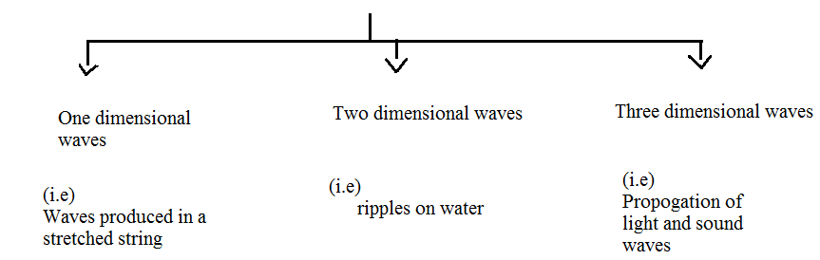

Based on the Transfer of Energy
- Standing waves (or stationary waves)
- Progressive wave
Standing waves remain confined to a region without any transfer of energy and momentum whereas the progressive waves transfer energy and momentum between the particles of the medium.

Transverse Wave Motion
The particles of the medium vibrate in a direction perpendicular to the direction of propagation of the wave. The region of maximum upward displacement is called the crest and the region of maximum downward displacement is called trough.
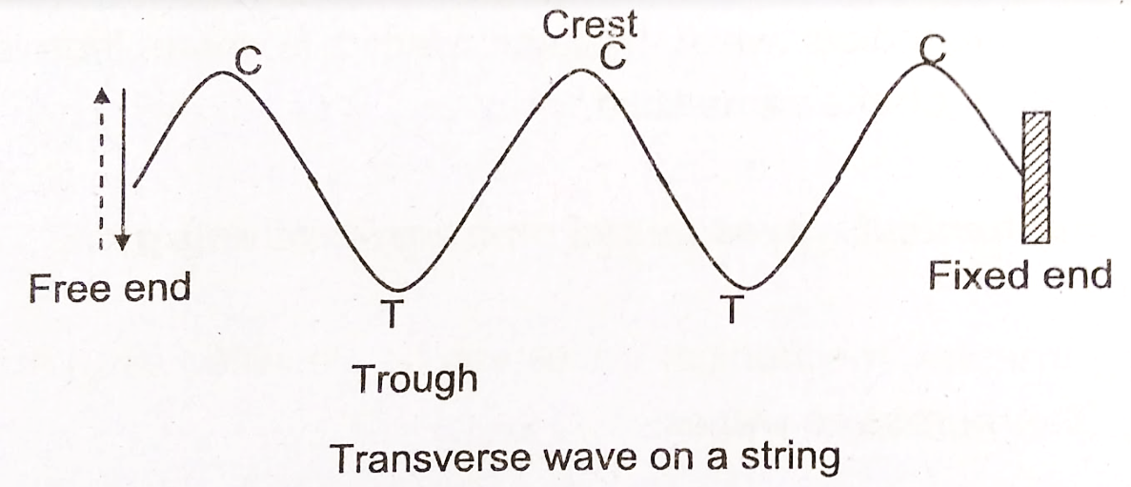

Longitudinal Wave Motion
The particles of the medium vibrate about their equilibrium position in a direction parallel to the direction of propagation of the wave is called a longitudinal waves. The region of high pressure is called compression and the region of low pressure is called rarefaction. For example, Sound waves
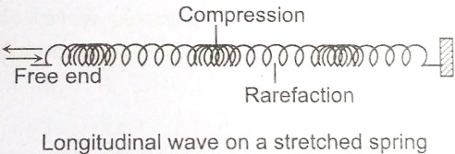

Travelling and Standing Waves
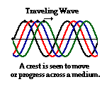
A mechanical wave is a disturbance that is created by a vibrating object and subsequently travels through a medium from one location to another, transporting energy as it moves. The mechanism by which a mechanical wave propagates itself through a medium involves particle interaction; one particle applies a push or pull on its adjacent neighbor, causing a displacement of that neighbor from the equilibrium or rest position. As a wave is observed traveling through a medium, a crest is seen moving along from particle to particle. This crest is followed by a trough that is in turn followed by the next crest. In fact, one would observe a distinct wave pattern (in the form of a sine wave) traveling through the medium. This type of wave pattern that is seen traveling through a medium is sometimes referred to as a traveling wave.
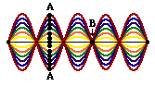It is however possible to have a wave confined to a given space in a medium and still produce a regular wave pattern that is readily discernible amidst the motion of the medium. For instance, if an elastic rope is held end-to-end and vibrated at just the right frequency, a wave pattern would be produced that assumes the shape of a sine wave and is seen to change over time. The wave pattern is only produced when one end of the rope is vibrated at just the right frequency. When the proper frequency is used, the interference of the incident wave and the reflected wave occur in such a manner that there are specific points along the medium that appear to be standing still. Because the observed wave pattern is characterized by points that appear to be standing still, the pattern is often called a standing wave pattern.

Plane waves - In a plane wave disturbances travel in the single direction. For example when a string is fixed at both ends and the string is plucked at one end, then transverse waves are generated in the string in which particles of the medium vibrate in one direction. So the transverse waves are plane waves.It is not possible in practice to have a true plane wave.

Spherical waves - A wave in which the disturbance is propagated outward in all directions from the source of wave is called a spherical wave. The light waves produced by a single light source, are spherical waves. During the propagation of light waves, the spherical wavefronts spread out in all directions.

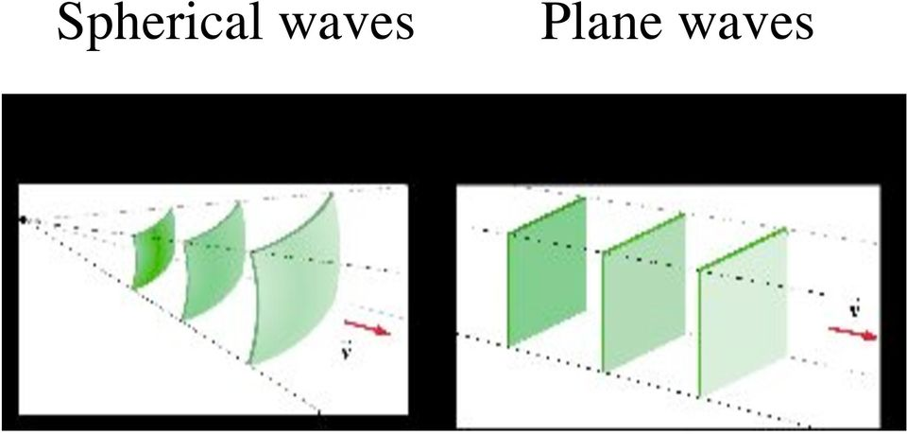

Characteristics of a Wave
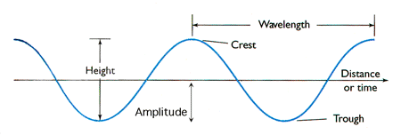

Crest = Highest point of the wave
Trough = Lowest point of the wave
Wavelength = Distance from one crest/trough to the next
Wave Height = Height from trough to crest
Wave steepness = ratio of wave height to wavelength
Amplitude = distance from the centre of wave to the bottom of the trough
Wave Period = time for one full wavelength to pass a given point

Amplitude :
The characteristic height of a peak and depth of a trough is called the amplitude of the wave. The vertical distance between the bottom of the trough and the top of the peak is twice the amplitude. Letter A is used for the amplitude of a wave. The units of amplitude are in metres (m).
Wavelength :
The distance between two adjacent (next to each other) peaks is the same no matter which two adjacent peaks you choose. So there is a fixed distance between the peaks. This distance which is a characteristic of the wave is called the wavelength.The units are metres (m).
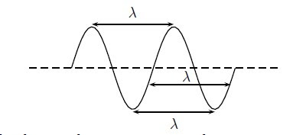

Time Period :
The time between two adjacent peaks is same and also the time between two adjacent troughs always the same. This is the time period and it is a characteristic of the wave denoted with the symbol T. It is the time it takes for any two adjacent points which are in phase to pass a fixed point. The units are seconds (s).

Frequency :
There is another way of characterising the time interval of a wave in the form of frequency and denoted as f. To determine the frequency, we find out what fraction of a wave goes by in 1 second by dividing 1 second by the time it takes T. The unit of frequency is the Hz, f=1/T
Speed :
The speed is the distance travelled by wave divided by the time taken to travel that distance. We know that the waves travel a distance equal to wavelength in a time T. This means that we can determine the speed.
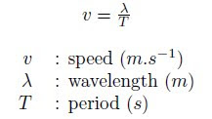
(Reference: Different Weblinks are used to compile the description of wave motion)

Please go through following videos which may help you in basic understanding of waves.

- https://youtu.be/XWVGL2h9jCM
(This link will demonstrate difference between travelling and standing waves.)
- https://youtu.be/0Anh9HthWgQ
- https://youtu.be/ZoyZy94do1k
(These links will demonstrate difference between transverse and longitudinal waves.)
- https://youtu.be/R8kCskG7hKI
(This link will explain characteristics of a wave)

