B.Sc. (H) Physics IV Semester
UPC- 32221403
Paper Name – Analog Systems and Applications
Topic – RC Coupled Amplifier and its Frequency Response (4 lectures)
- Understanding the working of Single Stage Common Emitter Amplifier:
Click on: https://youtu.be/1SX75vWfQNw
- Frequency response of Single Stage Common Emitter Amplifier:
Click on: https://youtu.be/hFlyThTeff0
- Working of Two Stage RC Coupled Amplifier:
Click on: https://youtu.be/WO0cTfg5B_Q
The frequency response of two stage amplifier is as follows. The roll off (or cut off) frequencies are marked at the 3dB gain (i.e. 70% of maximum gain).
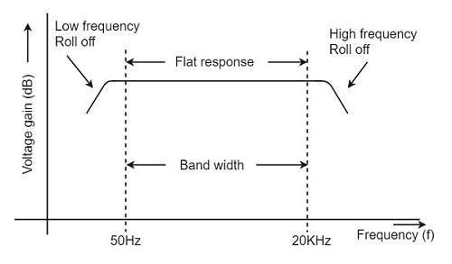
Important characteristics of an RC coupled amplifier:

- Used as an audio frequency (AF) amplifier
- It has a wide bandwidth
- Flat output with very less distortion
- Low gain at lower frequencies is due to coupling capacitors.
- Low gain at higher frequencies is due to wiring capacitances and short circuited shunt capacitances.

Advantages:
1. Inexpensive coupling method using only capacitor.
2. Large bandwidth.
3. Low distortion, flatter region.
4. Q point and DC bias conditions do not change.

Disadvantages:
1. As the gain reduces in LF/HF range, it can't be uses to amplify low/high frequencies.
2. Overall less gain (because of wide BW)
3. Low impedance matching
4. Becomes noisy with age.

Applications: RC coupled amplifiers are used in
1. Tape Recorders
2. TV, VCR, CD player
3. Stereo Amplifier
4. AF Amplifiers

-Dr Shivani Agarwal

