Study material
B.Sc. Life Science II
Medicinal Botany- theory
Unit 2-
Propagation of plants by grafting
Grafting is a horticultural techniques of asexual or vegetative methods of propagation, used to join parts from two or more plants so that they appear to grow as a single plant. In grafting, the upper part (scion) of one plant grows on the root system (rootstock) of another plant. The new plant that grows from the scion or bud will be exactly like the plant it came from. These methods of plant reproduction are usually chosen because cuttings from the desired plant root poorly (or not at all). Also, these methods give the plant a certain characteristic of the rootstock - for example, hardiness, drought tolerance, or disease resistance. Most woody nursery plants can be grafted or budded, but both processes are labor intensive and require a great deal of skill. For these reasons they can be expensive and come with no guarantee of success. Grafting can be performed only at very specific durations, when weather conditions and the physiological stage of plant growth are both optimum. For example, flowering pears can be grafted while dormant (in December and January) or budded during July and August.
Advantages-
- The newer varieties may offer enhanced insect or disease resistance, better drought tolerance, or higher yields.
- Optimize cross-pollination and pollination.
- Certain rootstocks have superior growth habits, disease and insect resistance, and drought tolerance.
- An interstock can be particularly valuable when the scion and rootstock are incompatible. In such cases, an interstock that is compatible with both rootstock and scion is used. An interstock could increase the disease resistance or cold hardiness of the scion. Plants also may be double worked to impart dwarfness or influence flowering and fruiting of a scion.
- Clones of numerous species of conifers cannot be economically reproduced from vegetative cuttings because the percentage of cuttings that root successfully is low.
- Numerous horticultural plants owe their beauty to the fact that these are grafted or budded onto a standard, especially those that have a weeping or cascading form.
- Repair damaged plants. Large trees or specimen plants can be damaged easily at or slightly above the soil line. The damage may be caused by maintenance equipment (such as lawn mowers, trenchers, or construction equipment), or by disease, rodents, or winter storms. The damage can often be repaired by planting several seedlings of the same species around the injured tree and grafting them above the injury. This procedure is referred to as inarching, approach grafting, or bridge grafting.
- Increase the growth rate of seedlings for them to flower and fruit by grafting more than one seedling onto a mature plant. This breeding saves duration, space and costs.
- Index viruses. Many plants carry viruses, although the symptoms may not always be obvious or even visible. The presence or absence of the virus in the suspect plant can be confirmed by grafting scions from the plant onto another plant that is highly susceptible and will display prominent symptoms.
Types of Grafts
Cleft Graft- for flowering and fruiting trees (apples, cherries, pears, and peaches) in order to change varieties that are difficult to root. Is usually done during the winter and early spring while both scion and rootstock are still dormant. It may be performed on main stems or on lateral or scaffold branches. The rootstock used for cleft grafting should range from 1 to 4 inches in diameter and should be straight grained. The scion should be about 1⁄4-inch in diameter, straight, and long enough to have at least three buds. Scions that are between 6 and 8 inches long are usually the easiest to use.
The stock should be sawed off with a clean, smooth cut perpendicular to the main axis of the stem to be grafted. Using a clefting tool wedge and a mallet, make a split or "cleft" from the center of the stock and down 2 to 3 inches. Remove the clefting tool wedge and drive the pick end of the tool into the center of the newly made cleft so that the stock can be held open while inserting the scion. One scion is usually inserted at each end of the cleft, so prepare two scions for each graft. Select scions that have three or four good buds. Using a sharp, clean grafting knife, start near the base of the lowest bud and make two opposing smooth-tapered cuts 1 to 2 inches long toward the basal end of the scion. Cut the side with the lowest bud slightly thicker than the opposite side. Be sure the basal end of the scion gradually tapers off along both sides. Insert a scion on each end of the cleft, with the wider side of the wedge facing outward. The cambium of each scion should contact the cambium of the rootstock. Remove the clefting tool from the cleft so that the rootstock can close. Pressure from the rootstock will hold the scions in place. Thoroughly seal all cut surfaces with grafting wax or grafting paint to keep out water and prevent drying. If both scions in the cleft "take," one will usually grow more rapidly than the other. After one growing season, choose the stronger scion and prune out the weaker.
Bark Graft- It is for flowering and fruiting trees. In contrast to cleft grafting, this technique can be applied to rootstock of larger diameter (4 to 12 inches) and is done during early spring when the bark slips easily from the wood but before major sap flow. The rootstock is severed with a sharp saw, leaving a clean cut as with cleft grafting.
Start at the cut surface of the rootstock and make a vertical slit through the bark where each scion can be inserted (2 inches long and spaced 1 inch apart). Since multiple scions are usually inserted around the cut surface of the rootstock, prepare several scions for each graft. Cut the base of each scion to a 11⁄2- to 2-inch tapered wedge on one side only. Loosen the bark slightly and insert the scion so that the wedge-shaped tapered surface of the scion is against the exposed wood under the flap of bark. Push the scion firmly down into place behind the flap of bark, replace the bark flap, and nail the scion in place by driving one or two wire brads through the bark and scion into the rootstock. Insert a scion every 3 to 4 inches around the cut perimeter of the rootstock. Seal all exposed surfaces with grafting wax or grafting paint. Once the scions have begun to grow, leave only the most vigorous one on each stub; prune out all the others. Bark grafts tend to form weak unions and therefore usually require staking or support during the first few years.
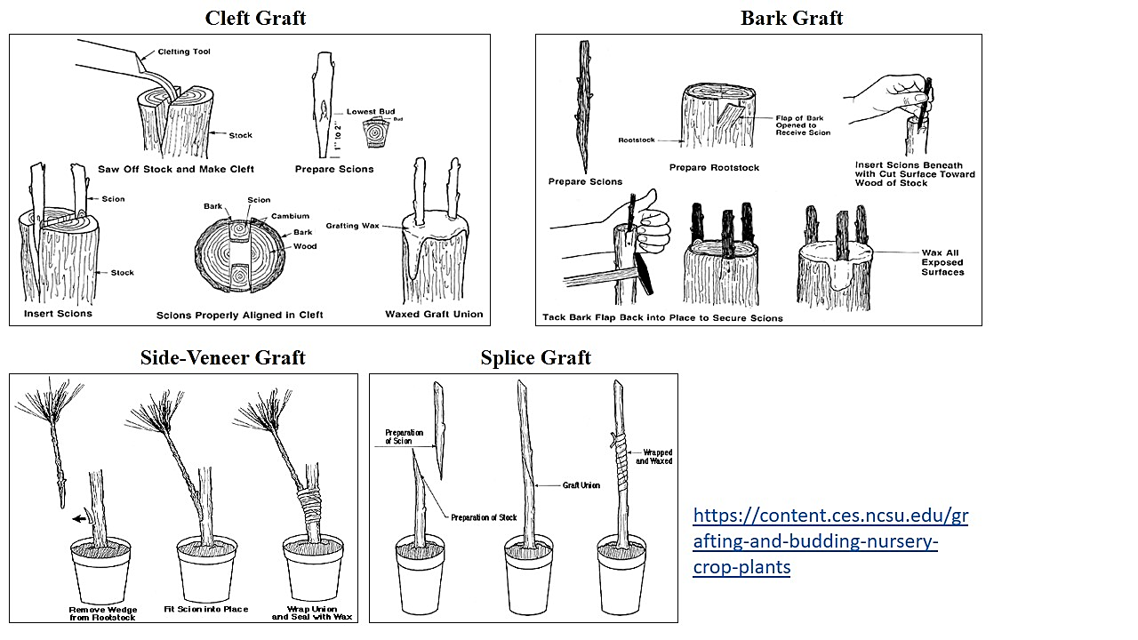
Side-Veneer Graft- Currently, it is the most popular way to graft conifers, especially those having a compact or dwarf form. Side-veneer grafting is usually done on potted rootstock.
Rootstock is grown in pots the season before grafting, allowed to go dormant, and then stored as with other container nursery stock. After exposure to cold weather for at least six weeks, the rootstock is brought into a cool greenhouse for a few days before grafting takes place to encourage renewed root growth. Make a shallow downward cut about 3⁄4-inch to 1 inch long at the base of the stem on the potted rootstock to expose a flap of bark with some wood still attached. Make an inward cut at the base so that the flap of bark and wood can be removed from the rootstock. Choose a scion with a diameter the same as or slightly smaller than the rootstock. Make a sloping cut 3⁄4-inch to 1 inch long at the base of the scion. (Use the bark grafting technique shown in. Insert the cut surface of the scion against the cut surface of the rootstock. Be certain that the cambia contact each other. Hold the scion in place using a rubber grafting strip, tape, or grafting twine. Seal the entire graft area with warm grafting wax or grafting paint. Remove the rubber or twine shortly after the union has healed. Never allow the binding material to girdle the stem.
Splice Graft- It is used to join a scion onto the stem of a rootstock or onto an intact rootpiece. This simple method is usually applied to herbaceous materials that callus or "knit" easily, or it is used on plants with a stem diameter of 1⁄2-inch or less. In splice grafting, both the stock and scion must be of the same diameter.
Cut off the rootstock using a diagonal cut 3⁄4-inch to 1 inch long. Make the same type of cut at the base of the scion. Fit the scion to the stock. Wrap this junction securely with a rubber grafting strip or twine. Seal the junction with grafting wax or grafting paint. Water rootstock sparingly until the graft knits. Over watering may cause sap to "drown" the scion. Be sure to remove the twine or strip as soon as the graft has healed.
Whip and Tongue Graft- It is most commonly used to graft nursery crops or woody ornamentals. Both the rootstock and scion should be of equal size and preferably no more than 1⁄2-inch in diameter. The technique is similar to splice grafting except that the whip on the rootstock holds the tongue of the scion in place (and vice versa). This leaves both hands free to wrap the joint. For the whip and tongue graft, make similar cuts on both the stock and scion. These cuts should be made with a single draw of the knife and should have a smooth surface so that the two can develop a good graft union. Up to this point, rootstock and scion are cut the same as for a splice graft.
Cut off the stock using a diagonal cut. The cut should be four to five times longer than the diameter of the stock to be grafted. Make the same kind of cut at the base of the scion. Next, place the blade of the knife across the cut end of the stock, halfway between the bark and pith (on the upper part of the cut surface). Use a single knife stroke to draw the blade down at an angle through the wood and pith. Stop at the base of the initial diagonal cut. This second cut must not follow the grain of the wood but should run parallel to the first cut. Prepare the scion in the same way. Fit the scion into the rootstock so that they interlock whip and tongue. Be certain that the cambia are aligned. Wrap the junction with a grafting strip or twine, and seal it with grafting wax or grafting paint. Never allow the binding material to girdle the stem.
Saddle Graft- The stock may be either field-grown or potted. Both rootstock and scion should be the same diameter. For best results, use saddle grafting on dormant stock in mid- to late winter. Stock should not be more than 1 inch in diameter.
Using two opposing upward strokes of the grafting knife, sever the top from the rootstock. The resulting cut should resemble an inverted V, with the surface of the cuts ranging from 1⁄2-inch to 1 inch long. Now reverse the technique to prepare the base of the scion. These cuts on the rootstock and scion must be the same length and have the same slope so that a maximum amount of cambial tissue will make contact when the two halves are joined. Place the V-notched scion onto the saddle of the rootstock. If rootstock and scion are the same diameter, cambial alignment is easier; otherwise adjust as needed. Wrap the graft with a grafting twine, tape, or strip, then seal it with grafting wax or grafting paint.
Bridge Graft- It is used to "bridge" a diseased or damaged area of a plant, usually at or near the base of the trunk. Such damage commonly results from contact with grading or lawn maintenance equipment, or it may be caused by rodents, cold temperatures, or disease organisms. The bridge graft provides support as well as a pipeline that allows water and nutrients to move across the damaged area. Bridge grafts are usually done in early spring just before active plant growth begins.
Select scions that are straight and about twice as long as the damaged area to be bridged. Make a 11⁄2- to 2-inch-long tapered cut on the same plane at each end of the scion. Remove any damaged tissue so the graft is on healthy stems. Cut a flap in the bark on the rootstock the same width as the scion and below the injury to be repaired. Gently fold the flap away from the stock, being careful not to tear the bark flap. Insert and secure the scion below the injury; push the scion under the flap with the cut portion of the scion against the wood of the injured stem or trunk. Then go back and insert and secure the scion above the injury following these same steps. Push the scion firmly into place. Pull the flap over the scion and tack it into place as described for bark grafting. Bridge grafts should be spaced about 3 to 4 inches apart across the damaged area. Secure all graft areas with warm grafting wax or grafting paint. During and after the healing period, remove any buds or shoots that develop on the scions.
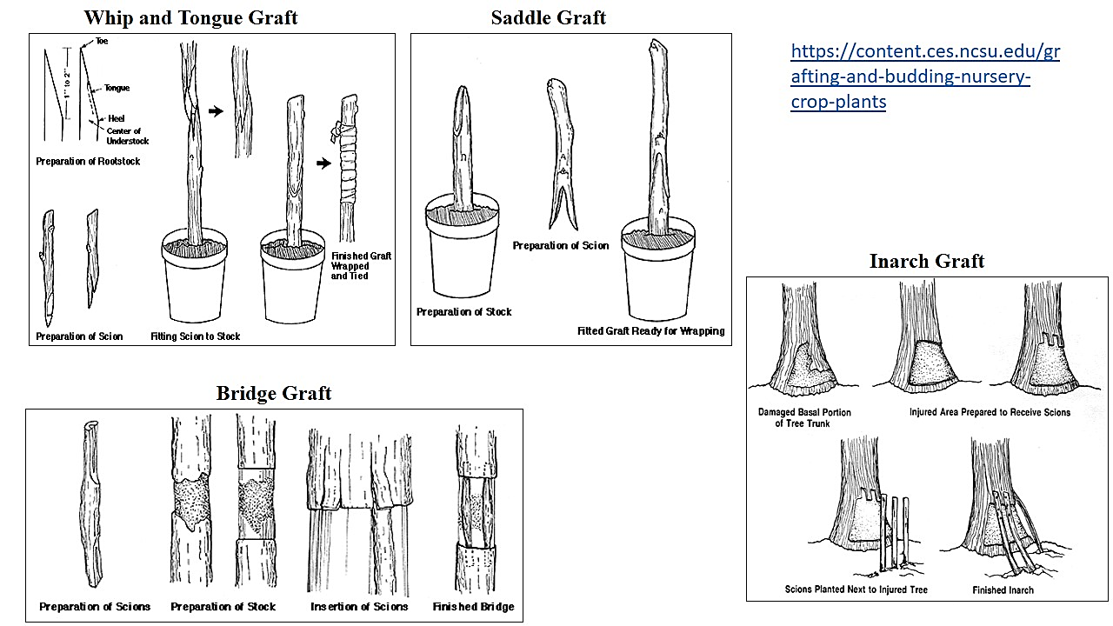
Inarch Graft- It is used to bypass or support a damaged or weakened area of a plant stem. Other than bridge grafting, the scion can be an existing shoot, sucker, or watersprout that is already growing below and extending above the injury. The scion may also be a shoot of the same species as the injured plant growing on its own root system next to the main trunk of the damaged tree. With the inarching technique, the tip of the scion is grafted in above the injury using the same method as for bark or bridge grafting.
Propagation of plants by budding
Budding is a horticultural techniques of asexual or vegetative methods of propagation, and is a grafting technique in which a single bud from the desired scion is used rather than an entire scion containing many buds. Most budding is done just before or during the growing season. However some species may be budded during the winter while they are dormant. Budding requires the same precautions as grafting. Be sure that the scion and rootstock are compatible, that the scion has mature buds, and that the cambia of the scion and rootstock match. Be especially careful to prevent drying or contamination of grafting materials. Generally, deciduous fruit and shade trees are well suited to budding. Rootstock can be grown in the field where it will be budded, or dormant liners can be transplanted into the field and then allowed to grow under moderate fertility. Since budding is generally done less than 4 inches above the soil surface, leaves and side branches must be removed from this portion of the rootstock to create a clean, smooth working area. The stem can be cleaned by brushing or rubbing it gently by hand or with a piece of soft cloth. Collect scion or budwood early in the day while temperatures are cool and the plants are still fully turgid. Mature buds are most desirable; discard terminal and younger buds because they are often not mature. To keep budwood from drying out, getting hot, or freezing (depending on the season), place it into plastic bags or wrap it in moist burlap as it is collected. Then move to a shaded or sheltered area to prepare the buds. Place budwood of only one variety in each labeled bag.
Budding Techniques
T-Budding- It is most commonly used for summer budding of apples, crabapples, dogwoods, peaches, and pears. T-budding must be one when the bark will slip and when cut, the bark easily lifts or peels in one uniform layer from the underlying wood without tearing.
Budding knives usually have a curved tip making it easier to cut a T-shaped slit. Insert the point of the knife and use a single motion to cut the top of the T. Then without removing the point of the knife, twist it perpendicularly to the original cut and rock the blade horizontally down the stem to make the vertical slit of the T. If bark is slipping properly, a slight twist of the knife at the end of this cut will pop open the flaps of the cut and make it easier to insert the bud. In practice, the top of the T is usually slanted slightly. This same type of cut can be made using two separate strokes, one vertical and one horizontal, and then using the back of the budding knife tip to pry up the flaps slightly. Although much slower, this technique may be easier. The bud to be inserted is often just a shield of bark with a bud attached or a very thin layer of wood with both the bark shield and bud attached. The cut surface of the rootstock and bud must stay clean. Do not touch these parts with your fingers. Also, do not set buds down or put them in your mouth. Insert the bud shield into the T flaps of the stock and slide it down to ensure that it makes intimate contact with the rootstock. Pull the cut together by winding a 4- or 5-inch long budding rubber around the stem to hold the flaps tightly over the bud shield and prevent drying. Secure the budding rubber by overlapping all windings and tucking the end under the last turn. Do not cover the bud.
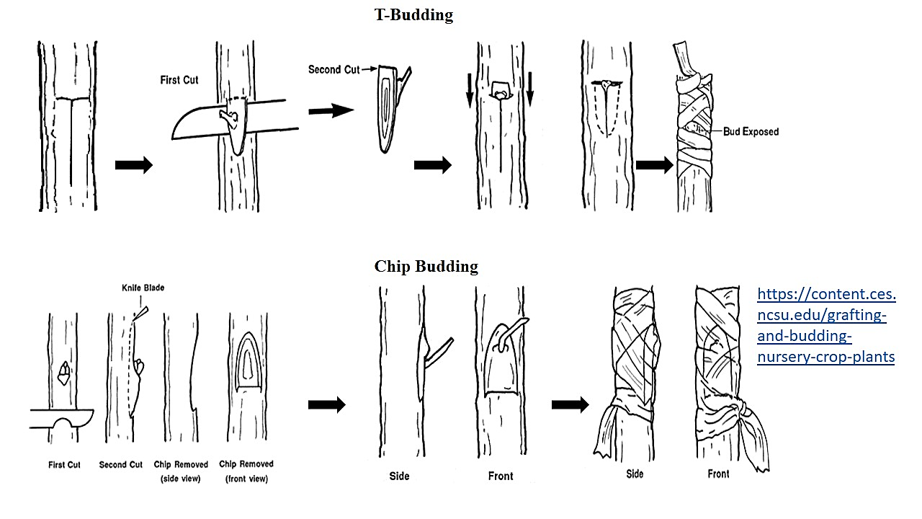
Chip Budding- It is a technique that may be used whenever mature buds are available. Because the bark does not have to "slip," the chip-budding season is longer than the T-budding season. Species whose bark does not slip easily without tearing - such as some maples - may be propagated more successfully by chip budding than by T-budding.
The cuts made in chip budding differ radically. The first cut on both stock and scion is made at a 45 to 60° downward angle to a depth of about 1⁄8-inch. After making this cut on a smooth part of the rootstock, start the second cut about 3⁄4-inch higher and draw the knife down to meet the first cut. Then remove the chip. Cuts on both the scion (to remove the bud) and the rootstock (to insert the bud) should be exactly the same. Although the exact location is not essential, the bud is usually positioned one-third of the way down from the beginning of the cut. If the bud shield is significantly narrower than the rootstock cut, line up one side exactly. Wrapping is extremely important in chip budding. If all exposed edges of the cut are not covered, the bud will dry out before it can take. Thin polyethylene tape is wrapped to overlap all of the injury, including the bud, and forms a miniature plastic greenhouse over the healing graft.

References-
http://ecoursesonline.iasri.res.in/mod/page/view.php?id=96807
http://ecoursesonline.iasri.res.in/mod/page/view.php?id=96808
https://content.ces.ncsu.edu/grafting-and-budding-nursery-crop-plants

