Study material
B.Sc. Life Science II
Medicinal Botany- theory
Unit 2-
Propagation of plants by Cuttings
Cutting is a method of vegetative propagation in which the portion of stem, leaf or root detached from mother plant induced to rooting and shooting in a proper medium. In this method rooting is induced after detaching parts from mother plant, so it is very necessary to have live cells of stem, leaf or roots up to rooting. For this purpose cuttings should be kept in proper environmental conditions.
Advantages-
- This type of propagation does not require the special technique as like budding or grafting.
- There is no problem of incompatibility with root stock which is always shown in budding and grafting.
- In a little period can get more than one feet high plant.
- The genetical characteristics of plants propagated by cutting are true to type (clonal propagation)
Limitations
- Certain fruit plants have difficulty in rooting.
- Possibility of mutating.
- Success differs largely according to plant species and season.
On the basis of plant part used and relative positions on a plant, cuttings are classified in various groups.
a. Stem cuttings: A stem cutting is any cutting taken from the main shoot of a plant or any side shoot growing from the same plant or stem. The shoots with high carbohydrate usually root better. Broadly, there are four types of stem cuttings, namely hardwood, softwood, semi-hardwood and herbaceous cuttings.
i. Hardwood cuttings: Cutting from mature and lignified stem of shrubs and trees are called as hardwood cuttings. Hardwood cuttings are prepared during dormant season, usually from one-year-old shoots of previous season’s growth. The size of cuttings varies depending upon the species. Usually, the cuttings of 25-30cm length are preferred. Each cutting should have at least three or more buds. While preparing the cutting, a straight cut is given at the base of shoot- below the node while a slanting cut, 1 to 2 cm above the bud is given at the top of cutting. However, in case of hollow pith species such as kiwifruit, top cut should also be close to bud to avoid drying up of top portion. For tropical and subtropical crops, straight cut is given at top in order to minimize transpiration loss and slant cut should be given at the base to expose more area for absorption of water and nutrients. This helps in maintaining the polarity of the shoot and if rain occurs, water does not accumulate on the tip of the cutting, which saves the cutting from fungal infection. A number of deciduous fruit plants of grape, kiwifruit, hazel nut, chest nut, fig, pomegranate, mulberry, plum, olive, gooseberry etc. are commercially propagated by hardwood cuttings.
ii. Semi-hardwood (green wood) cuttings: Semi-hard wood cuttings are those made from woody, broad-leaved evergreen species with partially matured wood. These types of cuttings are mostly used in evergreen fruit plants like mango, guava, lemon, jackfruit some shrubs and shrubby ornamental plants. The length of the cuttings varies from 7 to 20 cm. The cuttings are prepared by trimming the cuttings with a straight cut below the node and removing a few lower leaves. However, it is better to retain two-to-four leaves on the top of the cuttings. While planting 1/4th cutting should be inserted in the soil. The best time for taking such cuttings is summer, when new shoots have emerged and their wood is partially matured. It is necessary that leafy cuttings should be rooted under conditions when water loss from the leaves is minimum. Commercially, such cuttings are rooted under intermittent mist, fog or under polyethylene sheets laid over the cuttings.
iii. Softwood cuttings: Cuttings prepared from the soft-succulent and non-lignified shoots, which are not hard or woody, are called as softwood cuttings. Such types of cuttings are very prone to desiccation. Therefore, proper arrangement for controlling humidity is required. Usually the size of cutting is 5-5.7 cm but it may vary from species-to-species. In general, some leaves should be retained with this type of cuttings. The best time for preparing softwood cuttings is late summer. Softwood cuttings generally root easier and quicker than other types, but require more sophisticated equipment. Similarly, the temperature should be maintained 23 to 27ºC during rooting at the base of cuttings.
iv. Herbaceous cuttings: Herbaceous cuttings are made from succulent non-woody plants like geranium, chrysanthemum, coleus, carnation and many foliage crops. These are usually 7-15 cm long with few leaves retained at the upper end. These are rooted under the same conditions as that of softwood cuttings, requiring high relative humidity. Bottom heat is also useful for initiation of rooting process. Herbaceous cuttings of some plants exclude a sticky sap (as in geranium, pineapple, cactus etc.) that interferes with root initiation process. In such cases, basal ends of cuttings should be allowed to dry for few hours before planting. Generally, fruit plants are not propagated by herbaceous cuttings.
b. Root cuttings: Propagation by means of root cuttings is a simple and cheap method of vegetative propagation in species, which are difficult-to-propagate by other methods. In general, the plants, which produce suckers freely, are easily propagated by root cuttings. For preparation of root-cuttings, roots which are of 1cm thickness and 10-15cm long are cut into pieces. The best duration for taking root cutting is late winter or early spring, when roots are well supplied with stored food material. However, in temperate fruits, root cuttings are prepared in the month of December and are kept in warm place in moss grass or wet sand for callusing and are then transplanted in the nursery during February-March in the open beds. Blackberry and raspberry are commercially propagated by this method. However, kiwifruit, breadfruit, fig, rose, mulberry, apple, pear, peach, cherry and persimmon are also propagated by root cuttings.
c. Leaf cuttings: Propagation through leaf bud cuttings is partially useful in species where leaves develop root system but die because of non-development of shoot system. Leaf bud cuttings are particularly useful when planting material is scarce because each node in leaf can be used as cutting. Leaf bud cutting should preferably be prepared during growing season because buds if enter into dormancy may be difficult to force to active stage, thereby inhibit the rooting in such cuttings.
d. Leaf bud cuttings: A leaf bud cutting consists of a leaf blade, petiole and short piece of stem with attached axillary bud of actively growing leaves. In leaf bud cutting, 10-15 cm stem portion is used when propagating material is small. It is a useful method of propagation in blackberry, raspberry, lemon, camellia etc.

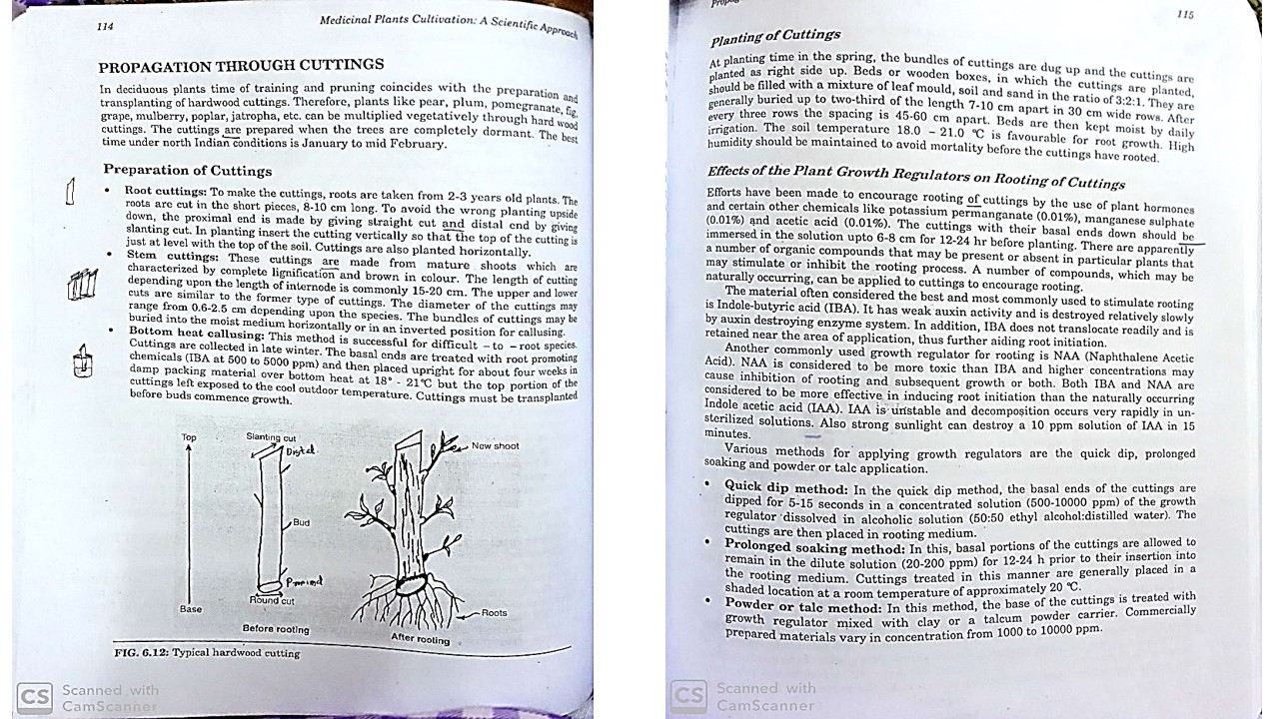
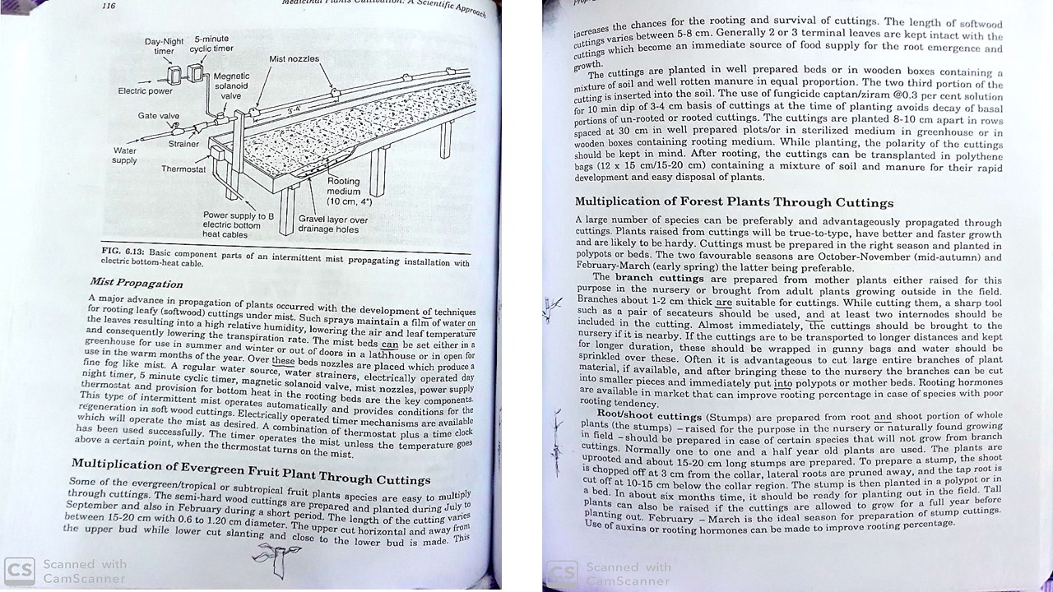

Propagation of plants by Layering
Layering is a form of rooting of cuttings in which adventitious roots are initiated on a stem while it is still attached to the plant. The rooted stem (layer) is then detached, transplanted, while later becomes a separate plant on its own roots. It is a natural mean of propagation in black raspberries and trailing blackberries or it may be induced artificially in many plants like clonal rootstocks of apple. In general, better rooting in the layers can be obtained by ringing or wounding, etiolation or by the use of rooting hormones like IBA, NAA and by providing favorable environmental conditions (temperature and humidity).
Advantages-
- It is an effective method of propagating species that usually do not root easily by cutting as in mango, litchi, filberts and kumquat etc.
- It is a natural method of propagation in blackberries and raspberries.
- It does not require precise control on water, relative humidity or temperature, as for other methods of propagation.
- Easy-to-perform and does not require much infrastructure.
Disadvantages-
- Costlier in areas where labor availability is a problem.
- Limited number of plants can be produced.
- Plants produced through layering have usually small brittle roots.
- The mortality rate is particularly higher in air layered plants.
Types of layering
The most commonly used systems to layer plants include:
Simple Layering- It consists of bending an intact shoot to the ground to cause adventitious roots to form. This method can be used to propagate a wide range of plants, indoor or outdoor on woody shrubs that produce numerous suckers. Layering is usually done in the early spring using flexible, dormant, one-year-old shoot-branches of the plant that can be bent easily to the ground. These shoots are bent and “pegged down” at a location 15 to 20 cm from the tip forming a “U”shape. Bending, twisting, cutting, or girdling at the bottom of the “U” stimulates rooting at that location. The base of the layer is covered with soil or other media, leaving the tip exposed.
Continuous or trench layering- It is the most common method of propagation for woody plants, which produce long vines and are difficult-to-propagate by other methods of propagation. Vigorous rootstocks of apple and walnut can easily be propagated by trench layering. In this method, it is important to establish a permanent row of plants to be propagated. The method the mother plants are planted at the base of a trench at an angle of 45⁰ in rows spaced 90 cm apart. The long and flexible stems of these plants are pegged down on the ground to form a continuous line of layered plants. The young shoots that arise from these plants are gradually mounded with moist soil up to a depth of 15-20 cm in autumn, winter or at the end of the growing season, depending on the species to be propagated.
Air layering (Marcottage, Gootee, Pot layerage)- It is an ancient method of layering, and now commercially used for propagation of a number of tropical and subtropical trees and shrubs including litchi, guava, mango, longan, persian lime, ficus, croton etc. Air layers are made in the spring or summer on stems of the previous season’s growth. The presence of active leaves on the layered shoot speeds root formation. Layers are prepared by making an upward cut about 5 cm long at or about the center of the shoot. The shoot is then girdled by removing a ring of bark about 2 cm wide. The upper part of wound is applied with IBA paste made in lanolin. The wound is covered with moist sphagnum moss in a way to provide complete cover to it. Polyethylene film is wrapped around the moss grass in such a way as to leave no opening, which could allow evaporation of moisture from the moss. The rooted layers may be severed from mother plant and may be planted in the nursery under shade.
Mound /Stool layering or stooling- It is a method of propagation in which the shoots/plants are cut back to the ground and soil or rooting medium is mounded around new sprouts/shoots to stimulate roots to develop at their bases. This method is commercially used to propagate apple, pear, quince, currants, gooseberry and other fruit crops. In stooling, the mother plant is headed back to 15 to 20 cm above ground level during dormant season. The new sprouts will arise within 2 months. The sprouts are then girdled near the base and rooting hormone (IBA), made in lanolin paste, is applied to the upper portion of the ring. The concentration of IBA depends on species to species but generally; 3,000 to 5,000 ppm is commonly used. These shoots are left as such for two days for proper absorption of rooting hormone, before they are covered with moist soil. Care should be taken to keep the soil heaps moist all the times. It facilitates rooting in the stools. The roots in shoots may emerge within 30 to 40 days. However, the rooted shoots should be severed from the mother plants only after 60 to 70 days and then planted in the nursery or field.
Tip layering- It is the simplest form of layering, which often occurs naturally. The tips of shoots are buried 5 to 10cm deep in the soil. Rooting in buried shoots takes place within a month. The new plants (layers) may be detached and transplanted in the soil during spring. It is a natural method of propagation for black berries, raspberries etc. However, currants, gooseberries and rambling roses can also be propagated by tip layering easily.

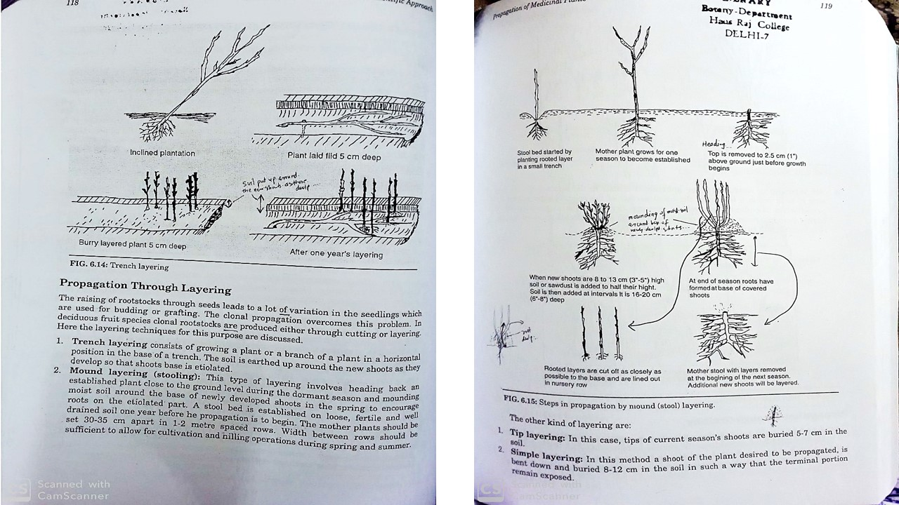
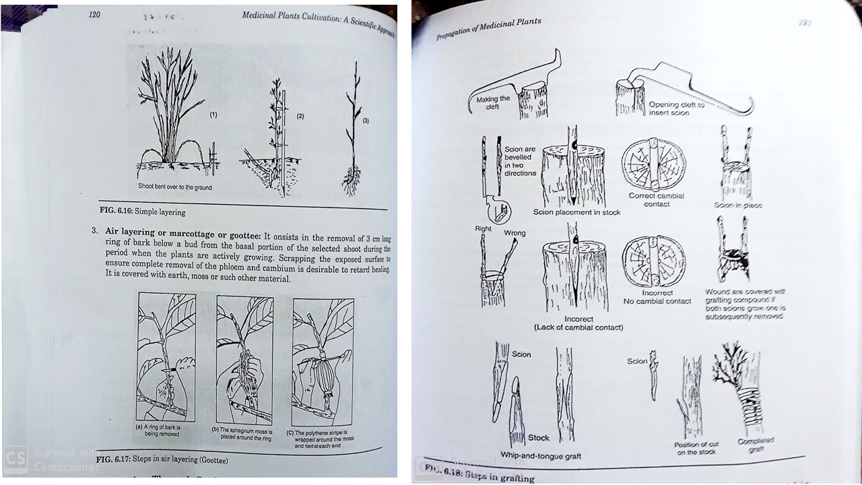
References-
http://ecoursesonline.iasri.res.in/mod/page/view.php?id=96807
http://ecoursesonline.iasri.res.in/mod/page/view.php?id=96808
Medicinal Plant Cultivating- A Scientific Approach by Purohit SS and Vyas SP, Agrobios.

