Study material
B.Sc. Life Science II
Medicinal Botany- theory
Unit 2-
Greenhouse
Greenhouses are framed or inflated structures covered with transparent or translucent material large enough to grow crops under partial or full controlled environmental conditions to get optimum growth and productivity.
FUNCTIONS OF GREENHOUSE:
- The yield may be 10-12 times higher than that of outdoor cultivation depending upon the type of greenhouse, type of crop, environmental control facilities.
- Reliability of crop increases under greenhouse cultivation.
- Ideally suited for vegetables and flower crops.
- Year round production of floricultural crops.
- Off-season production of vegetable and fruit crops.
- Disease-free and genetically superior transplants can be produced continuously.
- Efficient utilization of chemicals, pesticides to control pest and diseases.
- Water requirement of crops very limited and easy to control.
- Maintenance of stock plants, cultivating grafted plant-lets and micro propagated plant-lets.
- Hardening of tissue cultured plants
- Production of quality produce free of blemishes.
- Most useful in monitoring and controlling the instability of various ecological system.
- Modern techniques of Hydroponic (Soil less culture), Aeroponics and Nutrient film techniques are possible only under greenhouse cultivation.
TYPES OF GREENHOUSES
Greenhouse structures of various types are used for crop production. Although there are advantages in each type for a particular application, in general there is no single type of greenhouse, which can be constituted as the best. Different types of greenhouses are designed to meet the specific needs. The different types of greenhouses based on shape, utility, material and construction are briefly given below:
1. Greenhouse Type Based On Shape
For the purpose of classification, the uniqueness of cross section of the greenhouses can be considered as a factor. The commonly followed types of greenhouses based on shape are:
Lean-to type - Is used when a greenhouse is placed against the side of an existing building. It is built against a building, using the existing structure for one or more of its sides. The advantages of the lean-to type greenhouse are: It is usually close to available electricity, water, and heat; it is a least expensive structure; this design makes the best use of sunlight and minimizes the requirement of roof supports. Disadvantages of the lean-to type greenhouse are: Limited space, limited light, limited ventilation and temperature control is more difficult because the wall that the greenhouse is built on, may collect the sun's heat while the translucent cover of the greenhouse may lose heat rapidly.
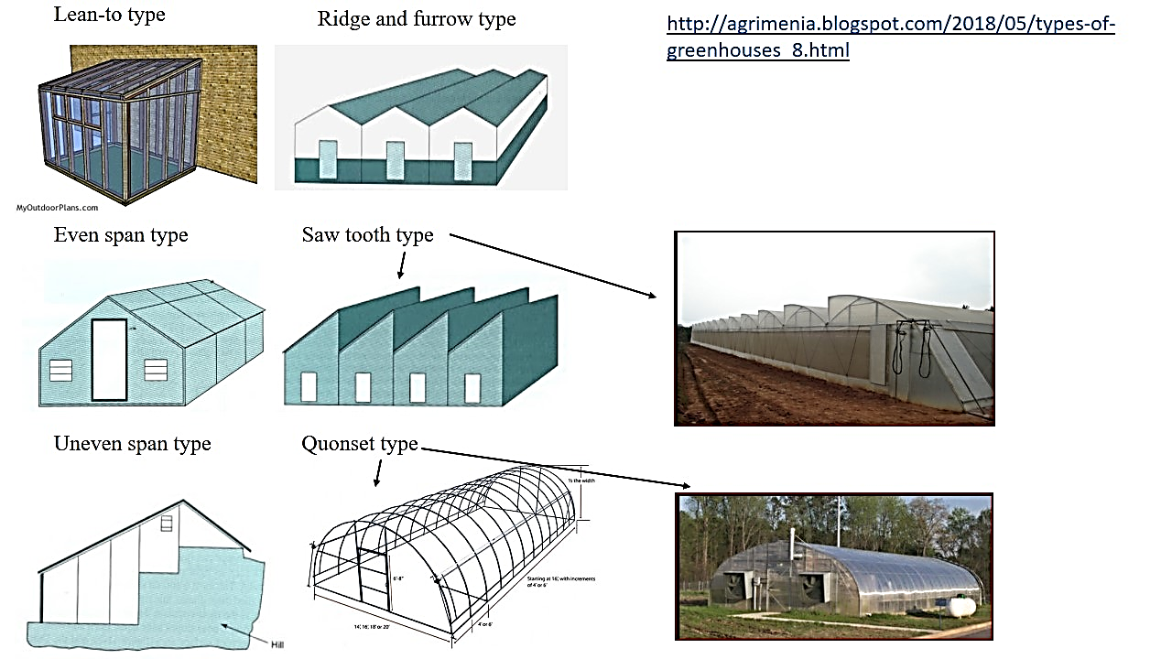
Even span type - It is the standard type and full-size structure, in which the two roof slopes are of equal pitch and width. This design is used for the greenhouse of small size, and it is constructed on level ground, and can attached to a house at one end. The cost of an even-span greenhouse is more than the cost of a lean-to type, but it has greater flexibility in design and provides for more plants. The design is better for air circulation to maintain uniform temperatures during the winter heating season.
Uneven span type – It is constructed on hilly terrain. The roofs are of unequal width that make the structure adaptable to the side slopes of hill. This type of greenhouses is seldom used now-a-days as it is not adaptable for automation.
Ridge and furrow type - Designs of this type use two or more A-frame greenhouses connected to one another along the length of the eave, which functions as furrow or gutter to carry rain and melted snow away. The side wall is eliminated between the greenhouses, which results in a structure with a single large interior space, which reduces labour, lowers the cost of automation, enhances personal management and reduces fuel consumption as there is less exposed wall area through which heat escapes.
[The eaves are the edges of the roof which overhang the face of a wall and, normally, project beyond the side of a building. The eaves form an overhang to throw water clear of the walls and may be highly decorated as part of an architectural style]
Saw tooth type – It is similar to ridge and furrow type greenhouses, but there is provision with a specific natural ventilation flow path.
Quonset type – In this the pipe arches or trusses are supported by pipe purling running along the length of the greenhouse, with a polyethylene covering material. These are less expensive and are useful when a small isolated cultural area is required. These houses can be either in free, standing style or connected in an interlocking ridge and furrow, in which truss members overlap sufficiently to allow a bed of plants to grow between the overlapping portions of adjacent houses. A single large cultural space thus exists that is better adapted to the automation and movement of labor.
[A truss is an asembly of beams or other elements that creates a rigid structure]
2. Greenhouse Type Based on Utility
Of the different utilities, artificial cooling and heating are more expensive and elaborate. Hence based on this, they are classified in to two types:
Greenhouses for active heating- During night, air temperature inside greenhouse decreases. To avoid freezing of plants, some amount of heat has to be supplied. Various methods are adopted to reduce the heat losses, by using double layer polyethylene, thermo pane glasses or heating systems, such as unit heaters, central heat, radiant heat and solar heating system.
Greenhouses for active cooling- During summer season, it is desirable to reduce the temperatures of greenhouse than the ambient temperatures, for effective crop growth. Hence large volumes of cooled air is drawn into greenhouse, by evaporative cooling pad with fan or fog cooling . This greenhouse is designed in such a way that it permits a roof opening of 40% and in some cases nearly 100%.
3. Greenhouse Type Based on Construction
The type of construction predominantly is influenced by structural material, though the covering material also influences the type. Higher the span, stronger should be the material and more structural members are used to make sturdy tissues. For smaller spans, simple designs like hoops can be followed. So based on construction, greenhouses can be classified as:
Wooden framed structures- with span less than 6 m, only wooden framed structures are used. Pine wood is commonly used as it is inexpensive and possesses the required strength. Timber locally available, with good strength, durability and machinability also can be used for the construction.
Pipe framed structures- Pipes are used for construction of greenhouses, with the span of around 12m. The side posts, columns, cross ties and purlins are constructed using pipes.
Truss framed structures- for span greater than or equal to 15m. Flat steel, tubular steel or angular iron is welded together to form a truss encompassing rafters, chords and struts. Struts are support members under compression and chords are support members under tension. Angle iron purlins running throughout the length of greenhouse are bolted to each truss. Columns are used only in very wide truss frame houses of 21.3 m or more. Most of the glass houses are of truss frame type, as these frames are best suited for pre-fabrication.
4. Greenhouse Type Based on Covering Material
Covering materials effect inside of the structure by altering the air temperature. The types of frames and method of fixing also varies with the covering material. Based on type of covering materials, the greenhouses are classified as:
Glass greenhouses- Glass as covering material has the advantage of greater interior light intensity. These greenhouses have higher air infiltration rate which leads to lower interior humidity and better disease prevention. Lean-to type, even span, ridge and furrow type of designs are used for construction of glass greenhouse.
Plastic film greenhouses- Flexible plastic films including polyethylene, polyester and polyvinyl chloride are used as covering material. Plastics are cheap and the cost of heating is less than glass greenhouses. The main disadvantage with plastic films is its short life. Quonset design is suitable for using this covering material.
Rigid panel greenhouses- Polyvinyl chloride rigid panels, fibre glass-reinforced plastic, acrylic and polycarbonate rigid panels are used as the covering material in the quonset type frames or ridge and furrow type frame. This material is more resistant to breakage and the light intensity is uniform throughout the greenhouse when compared to glass or plastic. High grade panels have long life span. The main disadvantage is that these panels tend to collect dust as well as to harbor algae, which results in darkening of the panels and subsequent reduction in the light transmission. There is significant danger of fire hazard.
5. Greenhouse Type Based on Cost of Construction
Are of three types:
Low cost Green House- it has les initial costs for establishment. Are naturally ventilated, with sufficient open area inside to allow the entry and exit of ambient air.
Medium cost Green House- the initial costs for establishment is more. Partial control of the environmental factors is necessary.
High cost Green House- the initial costs for establishment is high. The conditions inside are fully controlled. Are more efficient for plant propagation, particularly in extreme conditions.
References
http://ecoursesonline.iasri.res.in/mod/page/view.php?id=1606
http://ecoursesonline.iasri.res.in/mod/page/view.php?id=1604

