Formal Letter

In English there are a number of conventions that should be used when writing a formal or business letter. Furthermore, you try to write as simply and as clearly as possible, and not to make the letter longer than necessary. Remember not to use informal language like contractions.
Let us discuss the format of a Letter to the Editor.
The format of a letter to the editor of a Newspaper is as follows –
1. Sender’s address: The address and contact details of the sender are written here. Include email and phone number, if required or if mentioned in the question.
2. Date: The date is written below the sender’s address after Leaving one space or line.
3. Receiving Editor’s address: The address of the recipient of the mail i.e. the editor is written here.
4. Subject of the letter: The main purpose of the letter forms the subject. It must be written in one line. It must convey the matter for which the letter is written.
5. Salutation (Sir / Respected sir / Madam)
6. Body: The matter of the letter is written here. It is divided into 3 paragraphs as follows -
Paragraph 1: Introduce yourself and the purpose of writing the letter in brief.
Paragraph 2: Give a detail of the matter.
Paragraph 3: Conclude by mentioning what you expect from the editor. (For example, you may want him to highlight the issue in his newspaper / magazine).
7. Complimentary Closing
8. Sender’s name, signature and designation(if any)

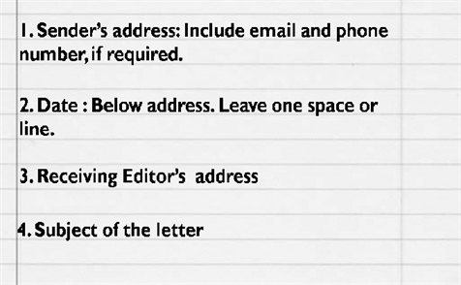
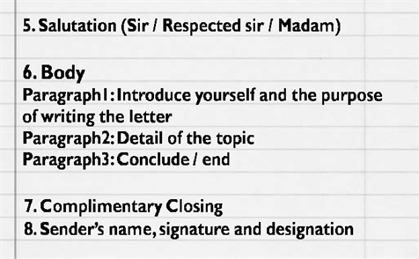

Sample Letter to the Editor

Q1. You are Radha G, member of NGO AWAAZ. Write a letter to the editor of a national daily for a public movement to clean the Yamuna river. (You must introduce yourself, describe how the people are to be blamed for polluting the river and suggest the need for installing water treatment plant to clean the river).
A.
33, Jal Vihar
Wazirabad, New Delhi - 33
Dated: 17 July 2017
The Editor
Hindustan Times
New Delhi.
Subject: Need for people’s movement for a clean Yamuna
Dear Editor
I am Radha G, member of NGO AWAAZ. I am writing to you in order to highlight the deteriorating condition of river Yamuna.
The city of Delhi is getting contaminated water from river Yamuna. The residents are to be blamed for this. They pollute the river with garbage, sewage and filth. The river water is full of bacteria, plastic, chemicals and other waste materials. It is unfit for consumption.
The people have been demanding a Water Treatment plant. The authorities have not yet responded to the repeated requests.
I request you to highlight the problem in your newspaper and arouse public interest. We all need to get together in order to get the plant set up in the area.
Thank You
Yours sincerely
Radha G
Member AWAAZ.

By Rajni
Guest Faculty

