B.Sc. (H) Botany III
DSE: IEM
Indicators of water quality
https://www.tandfonline.com/doi/abs/10.1080/09603123.2013.769201?src=recsys&journalCode=cije20
Water quality by the presence of pathogenic enteric microorganisms may affect human health. Coliform bacteria, Escherichia coli and coliphages are normally used as indicators of water quality. However, the presence of above-mentioned indicators do not always suggest the presence of human enteric viruses. It is important to study human enteric viruses in water. Human enteric viruses can tolerate fluctuating environmental conditions and survive in the environment for long periods becoming causal agents of diarrhoeal diseases. Therefore, the potential of human pathogenic viruses as significant indicators of water quality is emerging. Human Adenoviruses and other viruses have been proposed as suitable indices for the effective identification of such organisms of human contaminating water systems.
https://www.jove.com/science-education/10025/water-quality-analysis-via-indicator-organisms
Water quality analysis monitors anthropogenic influences such as pollutants, nutrients, pathogens, and any other constituent that can impact the water’s integrity as a resource. Fecal contamination contributes microbial pathogens that threaten plant, animal, and human health with disease or illness. Increasing water demands and strict quality standards require that water being supplied for human or environmental resources be monitored for low pathogen levels. However, monitoring each pathogen associated with fecal pollution is not feasible, as laboratory techniques involve extensive labor, time, and costs. Therefore, detection for indicator organisms provides a simple, rapid, and cost effective technique to monitor pathogens associated with unsanitary conditions. Indicators are easily detectable organisms whose presence correlates directly to one or more pathogens contaminating an environment. In order to be considered an appropriate indicator, an organism must meet the five following criterion:
- The indicator organism must be present when the pathogen is present, and the indicator organism must be absent when the pathogen is absent.
- The indicator organism’s concentration must correlate with the pathogen’s concentration. However, the indicator organism should always be found at higher numbers.
- The indicator organism should be able to survive easier and longer in the environment than the pathogen.
- Detection for the indicator organism should be easy, safe, and inexpensive.
- The indicator organism should be effective for all water types.
Most indicators are enteric organisms or viruses, which are commonly found in warm blooded mammalian and avian gastrointestinal systems, giving a direct connection to fecal contamination. However, many indicators can lack effectiveness due to a poor correlation with certain pathogens. Two of the most widely accepted bacterial indicator organisms are Escherichia coli and coliforms due to their fecal linkages, and ease in laboratory analysis.
http://home.iitk.ac.in/~anubha/Water3.pdf
To eliminate the ambiguity in the term ‘microbial indicator’, the following three groups are recognised:
- Process indicator- A group of organisms that demonstrates the efficacy of a process, such as total heterotrophic bacteria or total coliforms for chlorine disinfection.
- Faecal indicator- A group of organisms that indicates the presence of faecal contamination, such as the bacterial groups thermotolerant coliforms or E. coli. Hence, they only infer that pathogens may be present.
- Index and model organisms- A group/or species indicative of pathogen presence and behavior respectively, such as E. coli as an index for Salmonella and F-RNA coliphages as models of human enteric viruses.
Definitions of key faecal indicator micro-organisms-
- Coliforms: Gram-negative, non spore-forming, oxidase-negative, rod-shaped facultative anaerobic bacteria that ferment lactose (with β-galactosidase) to acid and gas within 24– 48h at 36±2°C. Not specific indicators of faecal pollution.
- Thermotolerant coliforms: Coliforms that produce acid and gas from lactose at 44.5±0.2°C within 24±2h, also known as faecal coliforms due to their role as faecal indicators.
- Escherichia coli (E. coli): Thermophilic coliforms that produce indole from tryptophan, but also defined now as coliforms able to produce β-glucuronidase (although taxonomically up to 10% of environmental E. coli may not). Most appropriate group of coliforms to indicate faecal pollution from warm-blooded animals.
- Faecal streptococci (FS): Gram-positive, catalase-negative cocci from selective media (e.g. azide dextrose broth or m Enterococcus agar) that grow on bile aesculin agar and at 45°C, belonging to the genera Enterococcus and Streptococcus possessing the Lancefield group D antigen.
- Enterococci: All faecal streptococci that grow at pH 9.6, 10° and 45°C and in 6.5% NaCl. Nearly all are members of the genus Enterococcus, and also fulfil the following criteria: resistance to 60°C for 30 min and ability to reduce 0.1% methylene blue. The enterococci are a subset of faecal streptococci that grow under the conditions outlined above. Alternatively, enterococci can be directly identified as micro-organisms capable of aerobic growth at 44±0.5°C and of hydrolysing 4-methlumbelliferyl-β-D-glucoside (MUD, detecting β-glucosidase activity by blue florescence at 366nm), in the presence of thallium acetate, nalidixic acid and 2,3,5-triphenyltetrazolium chloride (TTC, which is reduced to the red formazan) in the specified medium (ISO/FDIS 7899-1 1998).
- Sulphite-reducing clostridia (SRC): Gram-positive, spore-forming, non-motile, strictly anaerobic rods that reduce sulphite to H2S.
- Clostridium perfringens: As for SRC, but also ferment lactose, sucrose and inositol with the production of gas, produce a stormy clot fermentation with milk, reduce nitrate, hydrolyse gelatin and produce lecithinase and acid phosphatase. Bonde (1963) suggested that not all SRC in receiving waters are indicators of faecal pollution, hence C. perfringens is the appropriate indicator.
- Bifidobacteria: Obligately anaerobic, non-acid-fast, non-spore-forming, non-motile, Gram-positive bacilli which are highly pleomorphic and may exhibit branching bulbs (bifids), clubs, coccoid, coryneform, Y and V forms. They are all catalase-negative and ferment lactose (except the three insect species; B. asteroides, B. indicum and B. coryneforme) and one of the most numerous groups of bacteria in the faeces of warmblooded animals.
- Bacteriophages (phages): These are bacterial viruses and are ubiquitous in the environment. For water quality testing and to model human enteric viruses, most interest in somatic coliphages, male-specific RNA coliphages (F-RNA coliphages) and phages infecting Bacteroides fragilis.
- Coliphages: Somatic coliphages attack E. coli strains via the cell wall and include spherical phages of the family Microviridae and various tailed phages in 3 families. The F-RNA coliphages attack E. coli strains via the sex pili (F factor) and are single-stranded RNA non-tailed phages in four groups.
- Bacteroides fragilis bacteriophages: These infect one of the most abundant bacteria in the gut, belong to the family Siphoviridae with flexible tail (dsDNA, long non-contractile tails, capsids up to 60 nm). Phages to the host strain, B. fragilis HSP40 are considered to be human-specific, but phages to B. fragilis RYC2056 are more numerous and not human-specific.
Coliform identification schemes
Various classification schemes for coliforms have emerged. Differentiation of coliforms had come to a series of correlations that suggested indole production, gelatin liquefaction, sucrose fermentation and the Voges–Proskauer reaction were among the more important tests for determining faecal contamination. These developments culminated in the IMViC (Indole, Methyl red, Voges–Proskauer and Citrate) tests for the differentiation of faecal coliforms, soil coliforms and intermediates; these tests are still in use today.
Water sanitary engineers, however, require simple and rapid methods for the detection of faecal indicator bacteria. Hence, the simpler to identify coliform group, despite being less faecal-specific and broader (for which Escherichia, Klebsiella, Enterobacter and Citrobacter were considered the most common genera) was targeted. One of the generally accepted methods for coliforms was called the Multiple-Tube Fermentation Test.

Colilert is a defined substrate technology approach for simultaneous detection, specific identification, and confirmation for E. coli and total coliforms in water samples. This laboratory technique utilizes substrate nutrients specific to each indicator organisms’ metabolic pathway, enumerating only desired microorganisms, which release a signal when the bacteria alter the compound. Colilert can be performed as a presence-absence (P-A) test to indicate whether or not the organisms exist in the sample. This test is completed by dissolving the substrate into 100 mL water samples, incubating at 35 ± 0.5 °C for 24 h, and observing the color signals-
- In the presence of a coliform, the ortho-nitrophenyl-β-D-galactopyranoside (ONPG) nutrient is hydrolyzed by the coliform’s β-galactosidase enzyme. The product compound, ortho-nitrophenyl, is a chromogen that releases a color signal, turning the water yellow.
- In the presence of E. coli, the methylumbelliferyl-β-D-glucuronide (MUG) nutrient is cleaved by the bacteria’s glucuronidase enzyme, producing a methylumbelliferone product that fluoresces blue-green under ultraviolet light. The enzymatic activity of β-glucuronidase (GUD), which cleaves the substrate 4-methylumbelliferyl β-D-glucuronide (MUG), to release 4-methylumbelliferone (MU). When exposed to longwave (365 nm) UV light, MU exhibits a bluish fluorescence that is easily visualized in the medium or around the colonies. Over 95% of E. coli produces GUD, including anaerogenic (non-gas-producing) strains.
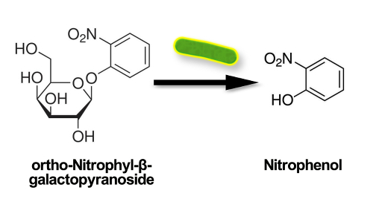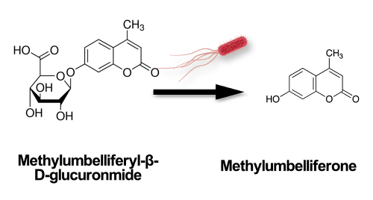
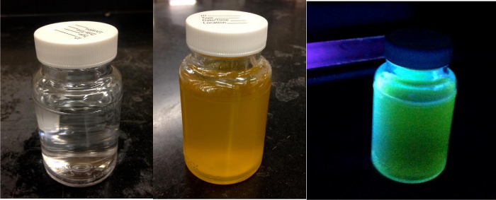
P-A test negative (left), coliform positive (middle), and E. coli positive (right).
http://www.biologydiscussion.com/micro-biology/top-3-experiments-on-environmental-microbiology/31423
Furthermore, certain bacterial species, particularly E. coli and related organisms designated as coliforms, faecal streptococci (S. faecalis) and Clostridium per-fringes, are normal inhabitants of the large intestine of humans and other animals and are consequently present in faeces. Thus, the presence of any of these bacterial species in water is evidence of faecal pollution of human or animal origin. The coliform group of bacteria includes all the aerobic and facultatively gram-negative, non-sporulating bacilli that produce acid and gas from fermentation of lactose. The classical species of this group are E. coli and Enterobacter aero-genes. These organisms are also related to other enteric genera viz. Salmonella, Shigella, Klebsiella, Proteus, Serratia, etc. gram-negative and non-sporulating forms. General’ scheme of laboratory testing for detection of coliform group in water is given below:
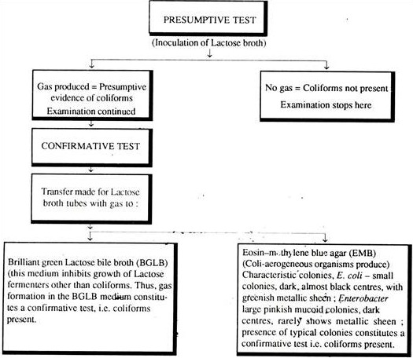
Fermentation of lactose broth and demonstration of gram-negative, non-sporulating bacilli constitute a positive completed test demonstrating the presence of some members of the coliform group in the sample examined.
The standard microbiological techniques involve successive steps:
- The Presumptive test
- The confirmatory test
- The complete test.
Requirements: Water samples, Lactose broth (Beef extract – 3 gm., Peptone – 5 gm., Lactose – 10 gm., Distilled water – 1 lit., pH – 6.8 to 7.8) in sterilised culture tubes, Sterilised petridishes, Pipette, Incubators, etc.
Preparation of the sample: The water sample is shaken vigorously 25 times and 1:10, 1: 100, 1: 1,000 distributions are made.
Presumptive test for coliform bacteria: 1 ml of diluted water sample is incubated in Lactose broth containing culture tubes at 37°C for one day. Each tube has Durham’s vial. The tubes are then tested for gas and acid production. The presence of gas indicates the positive presumptive test.
Confirmatory test for Coliform bacteria: This test is necessary only when the test samples show positive presumptive test. For this test, streaking is done on an eosin methylene blue (EMB) agar plate (Peptone – 10 g., Lactose – 5 g., Sucrose – 5 g., K2HPO4 – 2 g., Agar – 13.5 g., Eosin Y – 0.4 g., Methylene blue – 0.065 g., Water – 1 lit.), with the inoculum obtained from each of the lactose broth cultures showing production of gas. The plates are then incubated at 35 ± 1°C for 24 hours. If typical colonies develop, the confirmatory test may be considered positive.
Completed test for Coliform bacteria: A few isolated colonies arc picked up (and they are likely to be coliform groups) from each of the EMB plates and each one is incubated on a lactose broth fermentation tube and a nutrient agar slope. Then the tubes are incubated at 35 ± 1°C for 1 – 2 days. Finally the gas production capacity of these organisms on lactose broth is observed and gram stained preparation is made from nutrient agar slopes. The production of gas and observation of gram-negative non-spore forming rod-shaped bacteria in the nutrient agar media is satisfactory completed test for demonstrating the presence of coliform bacteria in the test samples. The presence of one such bacterium per 100 ml. of water makes the water polluted and it is not fit for drinking.
Precautions:
- The sample must be collected aseptically and carried to the laboratory in a sterilised bottle.
- The sample must be a representative sample.
- Contamination must be avoided during and after sampling.
- Testing should not be delayed.
Membrane-Filter Technique for Bacteriological Examination of Water: A sterilised disc is placed in a filtration unit. A volume of the water to be tested is drawn through this disc; the bacteria are retained on the surface of the membrane. Then the filter disc is removed and placed on an absorbent pad that has previously been saturated with the appropriate medium. Alternately, the disc can be placed on the surface of an agar medium in a petridish. On incubation, colonies will develop on the filter disc wherever bacteria were entrapped during filtration process. The membrane filter technique has several desirable features:
- A large volume of water sample can be examined. Theoretically, almost any volume of non-turbid water can be filtered through the disc, the organisms from any given volume being deposited on the disc.
- The membrane can be transferred from one medium to another for purpose of selection or differentiation of organisms.
- Results can be obtained more rapidly than by the conventional MPN standard methods.
- Quantitative estimation of certain bacterial types, e.g., coliforms, can be accomplished when appropriate media are used.
Requirements: Millipore filtration apparatus set, Sterilised disc, forceps, pipette and petridish, Enrichment broth (Yeast extract – 6 g., Peptone – 40 g., K2HPO4 – 3 g., NaCl – 5 g., Distilled water – 1 lit., pH – 7), Endo-medium broth (Peptone – 10 g., Lactose – 10 g., K2HPO4 – 3.5 g., Sodium sulphite – 2.5 g., Basic fuchsin – 0.5 g., Distilled water – 1 lit.), Brilliant green Lactose bile broth (Peptone – 10 g., Lactose – 10 g., Oxgall – 20 g., Bri­lliant green – 133 mg. Distilled water – 1 lit.), Reagents for biochemical tests.
Procedure: Approximately 1 ml of Endo-medium is added to the pad contained in the disc. The disc is then covered until the water sample has been filtered through the membrane. The filter is placed on a filter holder and clamped in position below the funnel, and the water sample (100 ml. for testing portability) is poured into the funnel and passed through the Millipore filter with the aid of a vacuum pump. The funnel is removed, and the filter disc, handled with sterilised forceps, placed on the pad previously impregnated with medium. The plates are incubated at 35°C for 20 hrs from which number of coliform colonies can be determined. Now the bacteria are seen as “sheen” colonies. For further verification of the identity of the coliform colonies the following biochemical tests can be made:
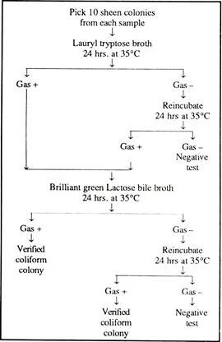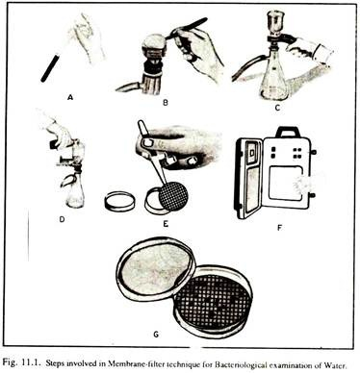
In general, gas production is considered to be the confirmatory test for coliform bacteria. Normally, this technique, with modifications, has been adopted for many microbiological procedures other than the examination of water.
Multiple Tube Method for Enumeration of Bacteria: The most probable number (MPN) concept for estimating bacteria is used on “multiple dilution to extinction” i.e. subdivision of the sample and is valuable for estimating the population of microorganisms where other bacterial species predominate, e.g. in contaminated water. The MPN method is most frequently used for determining coliform counts but specific types of other organisms can also be enumerated e.g. Salmonella, Staphylococcus, Streptococcus, Clostridium, Vibrio, Klebsiella or Aero-monas, by using appropriate selective broth and media.
https://microbeonline.com/probable-number-mpn-test-principle-procedure-results/
Most Probable Number (MPN) is a statistical, multi-step assay to estimate the concentration of viable microorganisms in a sample by means of replicate liquid broth growth in ten-fold dilutions. It is commonly used in estimating microbial populations in soils, waters, agricultural products and is particularly useful with samples that contain particulate material that interferes with plate count enumeration methods. MPN is most commonly applied for quality testing of water, to ensure whether the water is safe or not in terms of bacteria present in it. A group of bacteria commonly referred as fecal coliforms act as an indicator for fecal contamination of water. The presence of very few fecal coliform bacteria would indicate that a water probably contains no disease‑causing organisms, while the presence of large numbers of fecal coliform bacteria would indicate a very high probability that the water could contain disease‑producing organisms making the water unsafe for consumption.
Water to be tested is diluted serially and inoculated in lactose broth, coliforms if present in water utilize the lactose present in the medium to produce acid and gas. The presence of acid is indicated by color change of the medium and the presence of gas is detected as gas bubbles collected in the inverted durham tube present in the medium. The number of total coliforms is determined by counting the number of tubes giving positive reaction (both color change and gas production) and comparing the pattern of positive results (the number of tubes showing growth at each dilution) with standard statistical tables.
https://www.onlinebiologynotes.com/most-probable-number-mpn-method-for-counting-coliform/
MPN test is performed in 3 steps- Presumptive test, Confirmatory test, Completed test
Presumptive test: The presumptive test, is a screening test to sample water for the presence of coliform organisms. If the presumptive test is negative, no further testing is performed, and the water source is considered microbiologically safe. If, however, any tube in the series shows acid and gas, the water is considered unsafe and the confirmed test is performed on the tube displaying a positive reaction. Requirements : Medium: Lactose broth or Mac Conkey Broth or Lauryl tryptose (lactose) broth; Glasswares: Test tubes of various capacities (20ml, 10ml, 5ml), Durham tube; Others: Sterile pipettes. Prepare medium (either mac conkey broth or Lactose broth) in single and double strength concentration. MacConkey Broth and MacConkey medium (Peptone – 17 gm., Proteose peptone – 3 gm., Lactose – 10 gm., Bile salt – 1.5 gm., NaCl – 5 gm., Neutral red – 3 ml. Agar – 15 gm., Distilled water – 1 lit.), Brilliant green bile salt Lactose broth (BGBB), Peptone water (Peptone – 10 gm., NaCl – 5 gm., Distilled water – 1 lit.), Kovacs reagent (Para dimethyl amino Benz aldehyde-5 g., dissolved in 100 ml. mixture of conc. HCl and N-amyl alcohol in 1: 3 ratio), Ringers solution (NaCl-22.5 gm., KCl-0.105 g/lit. CaCl2 – 0.12 gin. ; NaHCO3 – 0.15 gm., Distilled water – 1 lit.), Autoclave, Hot air oven, Incubator, Water bath, Microscope, Test tube, Durham’s tubes, Pipettes, Water samples, Sterilized distilled water.
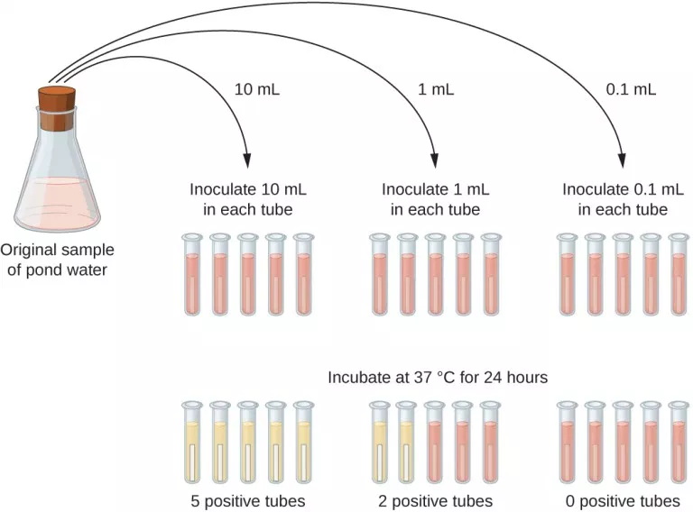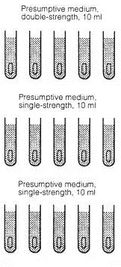
Three set of 5 test tubes are taken. 10 ml of double strengthen (refers to broth made up using twice the normal amount of broth powder) liquid media (MacConkey broth) is placed in each test tubes of set 1. Similarly, 10 ml of single strengthen liquid media is placed in each test tubes of 2nd set and 3rd. Lactose broth or lauryl sulphate broth or tryptose lauryl broth is used as liquid media for the test. Then, Durham’s tube is inserted in inverted position in each test tubes of all sets. All the test tubes are then cotton plugged and sterilized using autoclave for 15 minutes at 15 lb/inc2 pressure at 121 °C.
After cooling water sample is added in each test tubes as follows;
Add 10 ml water sample in each test tubes of set 1
Add 1 ml water sample in each test tubes of 2nd set
Add 0.1ml water sample in each test tubes of 3rd
Then incubate all test tubes at 35.5 °C for 24 hours. After incubation gas production in Durham’s tubes is observed. Tubes in which gas production is 10% or more is recorded as positive tube and tubes in which gas production is less than 10% is recorded as doubtful. Doubtful test tubes are further incubated for 24 hours and again gas production is noted. If gas production is still less than 10%, then tube is recorded as negative and are discarded. Doubtful result is given by other gas producing lactose fermenting bacteria other than coliforms such as Lactobacillus, Streptococci, Bacillus, Clostridium. Clostridium produces more than 10% gas but only after 48 hours of incubation.
All the positive test tubes are taken for confirmatory test.
For untreated water-
Take 5 tubes of double strength and 10 tubes of single strength for each water sample to be tested. Using a sterile pipette add 10 ml of water to 5 tubes containing 10 ml double strength medium. Similarly add 1 ml of water to 5 tubes containing 10 ml single strength medium and 0.1 ml water to remaining 5 tubes containing 10 ml single strength medium. Incubate all the tubes at 37°C for 24 hrs. If no tubes appear positive re-incubate up to 48 hrs. Compare the number of tubes giving positive reaction to a standard chart and record the number of bacteria present in it. For example: a water sample tested shows a result of 3–2–1 (3 × 10 ml positive, 2 × 1 ml positive, 1 × 0.1 ml positive) gives an MPN value of 17, i.e. the water sample contains an estimated 17 coliforms per 100 ml.

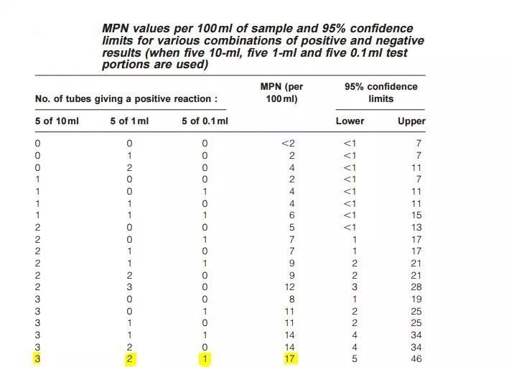

For treated water
For treated water: Dispense the double strength medium in 5 tubes (10ml in each tube) and 50 ml single strength medium in 1 bottle and add an durham tube in inverted position. Examine the tubes to make sure that the inner vial is full of liquid with no air bubbles. Sterilize by autoclaving at 15 lbs pressure (121°C) for 15 minutes.
Take 1 tube of single strength (50ml) and 5 tubes of double strength (10ml) for each water sample to be tested. Using a sterile pipette add 50 ml of water to the tubes containing 50 ml single strength medium. Similarly add 10 ml of water to 5 tubes containing 10 ml double strength medium Incubate the tubes at 37°C for 24 hrs. If no tubes appear positive re-incubate up to 48 hrs. Compare the number of tube giving positive reaction to a standard chart and record the number of bacteria present in it. For example: a water sample tested shows a result of 1-4 (1 × 50 ml positive, 4 × 10 ml positive) gives an MPN value of 16, i.e. the water sample contains an estimated 16 coliforms per 100 ml

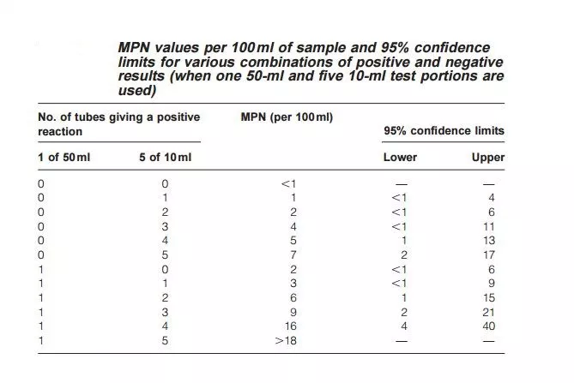

Confirmed test:
Positive tubes obtained from presumptive test are now confirmed for coliform. For confirmation of coliform, brilliant green lactose bile (BGLB) broth is used as culture media, because BGLB broth inhibits growth of gram positive bacteria such as lactobacillus, Streptococci, Bacillus and Clostridium. Coliforms can grow in this BGLB medium. For confirmation, one loopful of sample from each positive tubes obtained from presumptive test is inoculated in respective tubes containing Brilliant green lactose bile broth and incubated for 24 hours at 35.5 °C. Gas production 10% or more are recorded as positive while less than 10% is recorded as doubtful. Doubtful tubes are again incubated and the result is recorded. All the positive test tubes are now confirmed for presence of coliforms. Finally the number of bacteria present in water sample is determined from previous MPN chart. Alternatively number of coliforms can also be calculated by the formula;
Coliforms/100ml = numbers of positive tubes
_/ volume of samples in negative tubes * volume of samples in whole experiments
Some microrganisms other than coliforms also produce acid and gas from lactose fermentation. In order to confirm the presence of coliform, confirmatory test is done. From each of the fermentation tubes with positive results transfer one loopful of medium to:
- 3 ml lactose-broth or brilliant green lactose fermentation tube,
- to an agar slant and
- 3 ml tryptone water.
Incubate the inoculated lactose-broth fermentation tubes at 37°C and inspect gas formation after 24 ± 2 hours. If no gas production is seen, further incubate up to maximum of 48 ±3 hours to check gas production. The agar slants should be incubated at 37°C for 24± 2 hours and Gram-stained preparations made from the slants should be examined microscopically. The formation of gas in lactose broth and the demonstration of Gram negative, non-spore-forming bacilli in the corresponding agar indicates the presence of a member of the coliform group in the sample examined. The absence of gas formation in lactose broth or the failure to demonstrate Gram-negative, non-spore-forming bacilli in the corresponding agar slant constitutes a negative test (absence of coliforms in the tested sample).
Tryptone water Test- Incubate the tryptone water at (44.5 ±0.2°C) for 18-24 hours. Following incubation, add approximately 0.1ml of Kovacs reagent and mix gently. The presence of indole is indicated by a red colour in the Kovacs reagent, forming a film over the aqueous phase of the medium.
Confirmatory tests positive for indole, growth, and gas production show the presence of thermotolerant E. coli. Growth and gas production in the absence of indole confirm thermotolerant coliforms.

Completed test:
It is a final test in which a loopful of sample from positive confirmatory tubes is streaked on Eosin methylene blue agar or M-endo agar and incubated for 24 hours. Three types of colonies are obtained in culture media-
- Typical colony: they are pink colored with greenish metallic appearance or nucleated colony. Coliforms gives typical colony
- Atypical colony: they are pink and non-nucleated colony. Coliforms as well as other lactose fermenting organisms gives atypical colony
- Non-typical colony: they are non-pink colony given by non-coliforms.
Since some of the positive results from the confirmatory test may be false, it is desirable to do completed tests. For this inoculum from each positive tube of the confirmatory test is streaked on a plate of EMB or Endo agar. In this process, a loopful of sample from each positive BGLB tubes is streaked onto selective medium like Eosin Methylene Blue agar or Endo’s medium. One plate each is incubated at 37°C and another at 44.5± 0.2°C for 24 hours. High temperature incubation (44.5 ±0.2) is for detection of thermotolerant E.coli. Following incubation, all plates are examined for presence of typical colonies- Coliforms produce colonies with greenish metallic sheen which differentiates it from non-coliform colonies (show no sheen). Presence of typical colonies on high temperature (44.5 ± 0.2) indicate presence of thermotolerant E. coli.
Advantages of MPN :
- Ease of interpretation, either by observation or gas emission
- Sample toxins are diluted
- Effective method of analyzing highly turbid samples such as sediments, sludge, mud, etc.
- that cannot be analysed by membrane filtration.
Disadvantages of MPN:
- It takes a long time to get the results
- Results are not very accurate
- Requires more hardware (glassware) and media
- Probability of false positives
References and further reading- WHO: Multiple Tube Method for Thermotolerant (Faecal Coliform)

A standard method is given-
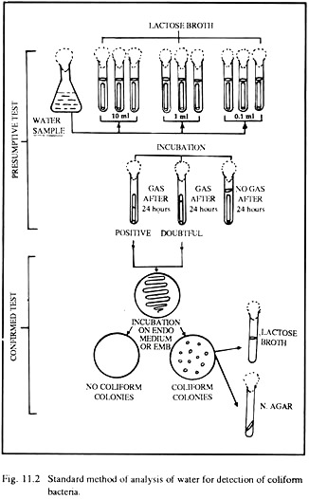
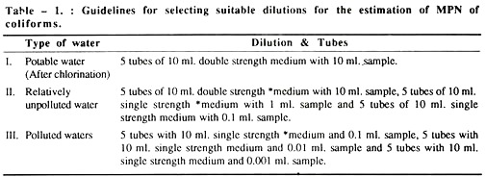
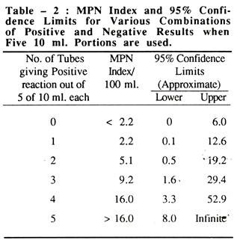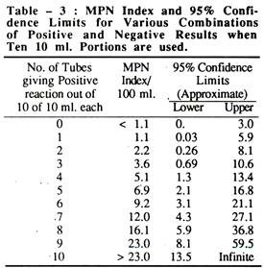
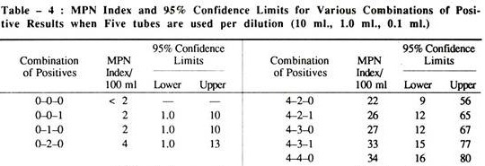
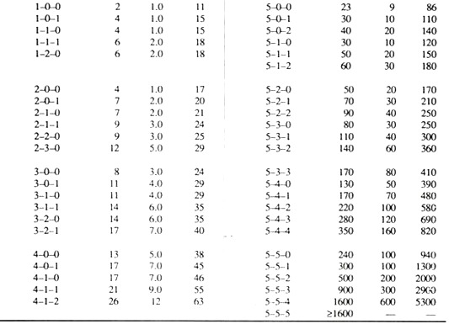

BOD, COD, TDS, TOC
https://www.chemeurope.com/en/whitepapers/126405/bod-cod-toc-and-tod-sum-parameters-in-environmental-analysis.html
http://www.biologydiscussion.com/water-pollution/measurement-of-water-pollution/10938
There are about 40 million organic compounds known in the environment which cannot be defined individually with considerable analytical effort and in short time. Therefore, the so-called sum parameters are used. These parameters reflect effect and material characteristics of one or more substances. The most popular sum parameter in waste water analysis are the BOD (biochemical oxygen demand), COD (chemical oxygen demand), TOD (total oxygen demand) and TOC (total organic carbon). The TOC reflects the organic pollution on the basis of a direct carbon determination. The other parameters are based on oxygen, which is required to reduce or to oxidise the samples' substances.
Biochemical oxygen demand- BOD
Biochemical oxygen demand is the most widely used parameter to measure the organic pollution in sewage as well as surface water. BOD basically involves the measurement of dissolved oxygen (DO) utilized by the microorganisms for the biochemical oxidation of organic matter. The demand for oxygen and the process of oxidation depends on the type and quantity of organic matter, temperature and type of the organism used. In general, biochemical oxygen demand is measured for an incubation period of five days (hence appropriately referred to as BOD5) at a temperature of 20°C. If the organic content of the sewage is high, it needs to be diluted for the measurement of BOD. Further, for waste water with less population of microorganisms, seeding with bacterial culture is necessary. BOD indicates the amount of organic matter present in the sewage. Thus, the more is organic content, the higher is the BOD. If the available oxygen (dissolved O2) is less than the BOD, the organic matter decomposes anaerobically, putrefies and produces foul smell. Thus, BOD is a measure of nuisance potential of sewage.
Limitations of BOD:
- BOD measures only biodegradable organic matter
- A high concentration of bacterial load is required
- For measuring BOD of toxic waste water, pretreatment is necessary
- Requires long period of incubation i.e. 5 days.
Despite these drawbacks, BOD is very widely used world over for practical and economic reasons.
https://en.wikipedia.org/wiki/Biochemical_oxygen_demand
BOD is the amount of dissolved oxygen needed (i.e. demanded) by aerobic biological organisms to break down organic material present in a given water sample at certain temperature over a specific time period. The BOD value is most commonly expressed in milligrams of oxygen consumed per litre of sample during 5 days of incubation at 20 °C and is often used as a surrogate of the degree of organic pollution of water. BOD reduction is used as a gauge of the effectiveness of wastewater treatment plants. BOD of wastewater effluents is used to indicate the short-term impact on the oxygen levels of the receiving water.
Most natural waters contain small quantities of organic compounds. Aquatic microorganisms have evolved to use some of these compounds as food. Microorganisms living in oxygenated waters use dissolved oxygen to oxidatively degrade the organic compounds, releasing energy which is used for growth and reproduction. Populations of these microorganisms tend to increase in proportion to the amount of food available. This microbial metabolism creates an oxygen demand proportional to the amount of organic compounds useful as food. Under some circumstances, microbial metabolism can consume dissolved oxygen faster than atmospheric oxygen can dissolve into the water or the autotrophic community (algae, cyanobacteria and macrophytes) can produce. Fish and aquatic insects may die when oxygen is depleted by microbial metabolism. Bod is the amount of oxygen required for microbial metabolism of organic compounds in water. This demand occurs over some variable period of time depending on temperature, nutrient concentrations, and the enzymes available to indigenous microbial populations. The amount of oxygen required to completely oxidize the organic compounds to carbon dioxide and water through generations of microbial growth, death, decay, and cannibalism is total biochemical oxygen demand (total BOD). Total BOD is of more significance to food webs than to water quality. Dissolved oxygen depletion is most likely to become evident during the initial aquatic microbial population explosion in response to a large amount of organic material. If the microbial population deoxygenates the water, however, that lack of oxygen imposes a limit on population growth of aerobic aquatic microbial organisms resulting in a longer term food surplus and oxygen deficit. Most pristine rivers will have a 5-day carbonaceous BOD below 1 mg/L. Moderately polluted rivers may have a BOD value in the range of 2 to 8 mg/L. Rivers may be considered severely polluted when BOD values exceed 8 mg/L. Municipal sewage that is efficiently treated by a three-stage process would have a value of about 20 mg/L or less. The BOD is used in measuring waste loadings to treatment plants and in evaluating the BOD-removal efficiency of such treatment systems.
Methods
Winkler published the methodology of a simple, accurate and direct dissolved oxygen analytical procedure in 1888. The Winkler method is still one of only two analytical techniques used to calibrate oxygen electrode meters; the other procedure is based on oxygen solubility at saturation as per Henry's law.
Dilution method- This standard method is recognized by EPA, which is labeled Method 5210B in the Standard Methods for the Examination of Water and Wastewater. In order to obtain BOD5, dissolved oxygen (DO) concentrations in a sample must be measured before and after the incubation period, and appropriately adjusted by the sample corresponding dilution factor. This analysis is performed using 300 ml incubation bottles in which buffered dilution water is dosed with seed microorganisms and stored for 5 days in the dark room at 20 °C to prevent DO production via photosynthesis. The bottles have traditionally been made of glass, which required cleaning and rinsing between samples. A SM 5210B approved, disposable, plastic BOD bottle is available which eliminates this step. In addition to the various dilutions of BOD samples, this procedure requires dilution water blanks, glucose glutamic acid (GGA) controls, and seed controls. The dilution water blank is used to confirm the quality of the dilution water that is used to dilute the other samples. This is necessary because impurities in the dilution water may cause significant alterations in the results. The GGA control is a standardized solution to determine the quality of the seed, where its recommended BOD5 concentration is 198 mg/l ± 30.5 mg/l. For measurement of carbonaceous BOD (cBOD), a nitrification inhibitor is added after the dilution water has been added to the sample. The inhibitor hinders the oxidation of ammonia nitrogen, which supplies the nitrogenous BOD (nBOD). When performing the BOD5 test, it is conventional practice to measure only cBOD because nitrogenous demand does not reflect the oxygen demand from organic matter. This is because nBOD is generated by the breakdown of proteins, whereas cBOD is produced by the breakdown of organic molecules.
https://vlab.amrita.edu/?sub=3&brch=272&sim=1430&cnt=2
All the aquatic animals rely on the oxygen present in the water (dissolved oxygen) to live. Aquatic microorganisms use the organic matter discharged into the water as food source. Common natural sources of organic matter include plant decay and leaf fall. Bacteria will break down this organic matter using the dissolved oxygen in the water and there by produce less complex organic substances. With increased disposal of waste materials (including organic compounds), the utility of dissolved oxygen by the microorganisms will also increased. So the water becomes depleted in oxygen. In this anaerobic condition, microorganisms will produce offensive products and may result in undesirable effects like fish asphyxiation. So the amount of dissolved oxygen in the water is an indicator of the quality of water. Biological oxygen demand is a widely used technique to express the concentration of organic matter in waste water samples. It is a measure of the amount of dissolved oxygen used by microorganisms in the water. If the amount of organic matter in sewage is more, the more oxygen will be utilized by microorganisms to degrade dumping sewage which containing high BOD value. Digestion of these organic compounds in neutral ecosystem such as lakes, rivers etc. can deplete available oxygen and result in fish asphyxiation. The BOD of a water sample is generally measured by incubating the sample at 20ºC for 5 days in the dark room under aerobic condition (in BOD incubator). In the water samples where more than 70% of initial oxygen is consumed, it is necessary to aerate or oxygenate and dilute the sample with BOD free water (de ionized glass distilled water) pass through a column of activated carbon and redistilled to avoid O2 stress. Under alkaline conditions (by adding Alkaline-iodide-azide), the manganese sulphate produces a white precipitate of manganese hydroxide. This reacts with the dissolved oxygen present in the sample to form a brown precipitate. On acidic condition, manganese diverts to its divalent state and release iodine. This released iodine is titrated against Sodium thiosulphate using starch as an indicator.
https://serc.carleton.edu/microbelife/research_methods/environ_sampling/oxygen.html
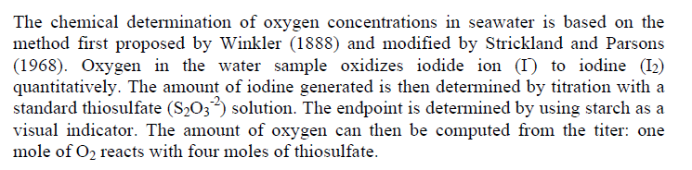
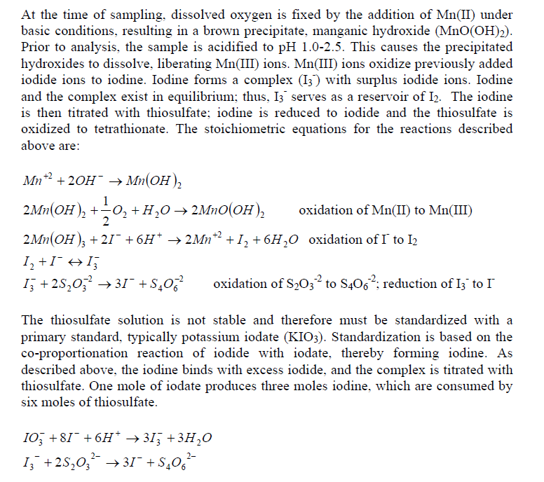

- Carefully fill a 300-mL glass Biological Oxygen Demand (BOD) stoppered bottle brim-full with sample water.
- Immediately add 2mL of manganese sulfate to the collection bottle by inserting the calibrated pipette just below the surface of the liquid. (If the reagent is added above the sample surface, you will introduce oxygen into the sample.) Squeeze the pipette slowly so no bubbles are introduced via the pipette.
- Add 2 mL of alkali-iodide-azide reagent in the same manner.
- Stopper the bottle with care to be sure no air is introduced. Mix the sample by inverting several times. Check for air bubbles; discard the sample and start over if any are seen. If oxygen is present, a brownish-orange cloud of precipitate or floc will appear. When this floc has settle to the bottom, mix the sample by turning it upside down several times and let it settle again.
- Add 2 mL of concentrated sulfuric acid via a pipette held just above the surface of the sample. Carefully stopper and invert several times to dissolve the floc. At this point, the sample is "fixed" and can be stored for up to 8 hours if kept in a cool, dark place. As an added precaution, squirt distilled water along the stopper, and cap the bottle with aluminum foil and a rubber band during the storage period.
- In a glass flask, titrate 201 mL of the sample with sodium thiosulfate to a pale straw color. Titrate by slowly dropping titrant solution from a calibrated pipette into the flask and continually stirring or swirling the sample water.
- Add 2 mL of starch solution so a blue color forms.
- Continue slowly titrating until the sample turns clear. As this experiment reaches the endpoint, it will take only one drop of the titrant to eliminate the blue color. Be especially careful that each drop is fully mixed into the sample before adding the next. It is sometimes helpful to hold the flask up to a white sheet of paper to check for absence of the blue color.
- The concentration of dissolved oxygen in the sample is equivalent to the number of milliliters of titrant used. Each mL of sodium thiosulfate added in steps 6 and 8 equals 1 mg/L dissolved oxygen.
The total number of milliliters of titrant used in steps 6-8 equals the total dissolved oxygen in the sample in mg/L. Oxygen saturation is temperature dependent - gas is more soluble in cold waters, hence cold waters generally have higher dissolved oxygen concentrations. Dissolved oxygen also depends on salinity and elevation, or partial pressure. The Winkler Method is a technique used to measure dissolved oxygen in freshwater systems. Dissolved oxygen is used as an indicator of the health of a water body, where higher dissolved oxygen concentrations are correlated with high productivity and little pollution. This test is performed on-site, as delays between sample collection and testing may result in an alteration in oxygen content. The Winkler Method uses titration to determine dissolved oxygen in the water sample. A sample bottle is filled completely with water (no air is left to skew the results). The dissolved oxygen in the sample is then "fixed" by adding a series of reagents that form an acid compound that is then titrated with a neutralizing compound that results in a color change. The point of color change is called the "endpoint," which coincides with the dissolved oxygen concentration in the sample. Dissolved oxygen analysis is best done in the field, as the sample will be less altered by atmospheric equilibration. Dissolved oxygen analysis can be used to determine: the health or cleanliness of a lake or stream, the amount and type of biomass a freshwater system can support, the amount of decomposition occurring in the lake or stream.
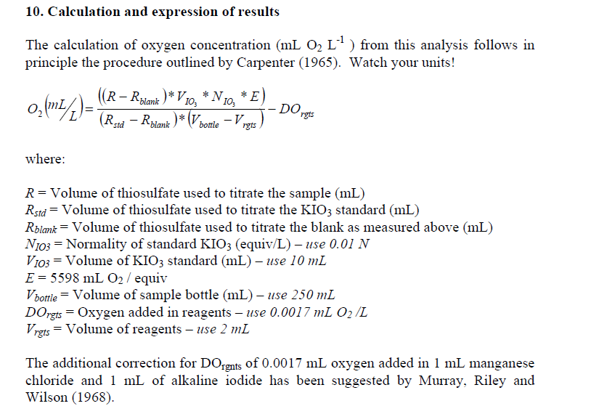
Manometric method- This method is limited to the measurement of the oxygen consumption due only to carbonaceous oxidation. Ammonia oxidation is inhibited. The sample is kept in a sealed container fitted with a pressure sensor. A substance that absorbs carbon dioxide (typically lithium hydroxide) is added in the container above the sample level. The sample is stored in conditions identical to the dilution method. Oxygen is consumed and, as ammonia oxidation is inhibited, carbon dioxide is released. The total amount of gas, and thus the pressure, decreases because carbon dioxide is absorbed. From the drop of pressure, the sensor electronics computes and displays the consumed quantity of oxygen. The main advantages of this method compared to the dilution method are
- simplicity: no dilution of sample required, no seeding, no blank sample
- direct reading of BOD value
- continuous display of BOD value at the current incubation time.
Biosensor- An alternative to measure BOD is the development of biosensors, which are devices for the detection of an analyte that combines a biological component with a physicochemical detector component. Enzymes are the most widely used biological sensing elements in the fabrication of biosensors. Their application in biosensor construction is limited by the tedious, duration -consuming and costly enzyme purification methods. Microorganisms provide an ideal alternative to these bottlenecks. Many microorganisms useful for BOD assessment are relatively easy to maintain in pure cultures, grow and harvest at low cost. Moreover, the use of microbes in the field of biosensors has opened up new possibilities and advantages such as ease of handling, preparation and low cost of device. A number of pure cultures, e.g. Trichosporon cutaneum, Bacillus cereus, Klebsiella oxytoca, Pseudomonas sp. etc. individually, have been used by many workers for the construction of BOD biosensor. On the other hand, many workers have immobilized activated sludge, or a mixture of two or three bacterial species and on various membranes for the construction of BOD biosensor. The most commonly used membranes were polyvinyl alcohol, porous hydrophilic membranes etc. A defined microbial consortium can be formed by conducting a systematic study, i.e. pre-testing of selected micro-organisms for use as a seeding material in BOD analysis of a wide variety of industrial effluents. Such a formulated consortium can be immobilized on suitable membrane, i.e. charged nylon membrane. Charged nylon membrane is suitable for microbial immobilization, due to the specific binding between negatively charged bacterial cell and positively charged nylon membrane.
The advantages of the nylon membrane over the other membranes are : The dual binding, i.e. Adsorption as well as entrapment, thus resulting in a more stable immobilized membrane. Such specific Microbial consortium based BOD analytical devices, may find great application in monitoring of the degree of pollutant strength, in a wide variety of industrial waste water within a very short time. Consequently, biosensors are now commercially available, but have several limitations such as their high maintenance costs, limited run lengths due to the need for reactivation, and the inability to respond to changing quality characteristics as would normally occur in wastewater treatment streams; e.g. diffusion processes of the biodegradable organic matter into the membrane and different responses by different microbial species which lead to problems with the reproducibility of result. Another important limitation is the uncertainty associated with the calibration function for translating the BOD substitute into the real BOD.
Fluorescent- It is developed using a resazurin derivative which reveals the extent of oxygen uptake by micro-organisms for organic matter mineralization. An electrode is developed based on the luminescence emission of a photo-active chemical compound and the quenching of that emission by oxygen. This quenching photophysics mechanism is described by the Stern–Volmer equation for dissolved oxygen in a solution. The determination of oxygen concentration by luminescence quenching has a linear response over a broad range of oxygen concentrations and has excellent accuracy and reproducibility.
Polargraphic method- The development of an analytical instrument that utilizes the reduction-oxidation (redox) chemistry of oxygen in the presence of dissimilar metal electrodes was introduced during the 1950s. This redox electrode utilized an oxygen-permeable membrane to allow the diffusion of the gas into an electrochemical cell and its concentration determined by polarographic or galvanic electrodes. This analytical method is sensitive and accurate down to levels of ± 0.1 mg/l dissolved oxygen. Calibration of the redox electrode of this membrane electrode still requires the use of the Henry's law table or the Winkler test for dissolved oxygen.
Dissolved oxygen probes of Membrane and luminescence- An analytical instrument that utilizes the reduction-oxidation (redox) chemistry of oxygen in the presence of dissimilar metal electrodes was introduced during the 1950s. This redox electrode (also known as dissolved oxygen sensor) utilized an oxygen-permeable membrane to allow the diffusion of the gas into an electrochemical cell and its concentration determined by polarographic or galvanic electrodes. This analytical method is sensitive and accurate to down to levels of ± 0.1 mg/l dissolved oxygen. Calibration of the redox electrode of this membrane electrode still requires the use of the Henry's law table or the Winkler test for dissolved oxygen.

Chemical oxygen demand (COD)
https://en.wikipedia.org/wiki/Chemical_oxygen_demand
In environmental chemistry, the chemical oxygen demand (COD) is an indicative measure of the amount of oxygen that can be consumed by reactions in a measured solution. It is commonly expressed in mass of oxygen consumed over volume of solution which in SI units is milligrams per litre (mg/L). A COD test can be used to easily quantify the amount of organics in water. The most common application of COD is in quantifying the amount of oxidizable pollutants found in surface water (e.g. lakes and rivers) or wastewater. COD is useful in terms of water quality by providing a metric to determine the effect an effluent will have on the receiving body, much like biochemical oxygen demand (BOD). The COD value has been developed analogically to the BOD measurement. Since there are many organics which are rather hard or not possible to decompose biologically, a parameter has been defined indicating the amount of oxygen which would be needed when all organic ingredients would be oxidised completely. As, the oxidation takes place chemically, the chemical oxygen demand can only be defined indirectly. A chemical oxidant is added to the sample in question, the consumption of which is then determined. The internationally dominant method today is the 'Dichromate' method, which is characterized by the acidification of the sample with sulphuric acid and the addition of silver sulphate. To avoid false measurements in chloride-containing samples, the chloride must be masked by mercuric sulphate befre. Due to the application of hazardous chemicals and having an analysis time of 2 hours the method is not suitable for online use.
The basis for the COD test is that nearly all organic compounds can be fully oxidized to carbon dioxide with a strong oxidizing agent under acidic conditions. Dichromate, the oxidizing agent for COD determination, does not oxidize ammonia into nitrate, so nitrification is not included in the standard COD test. Potassium dichromate is a strong oxidizing agent under acidic conditions. Acidity is usually achieved by the addition of sulfuric acid. Most commonly, a 0.25 N solution of potassium dichromate is used for COD determination, although for samples with COD below 50 mg/L, a lower concentration of potassium dichromate is preferred. In the process of oxidizing the organic substances found in the water sample, potassium dichromate is reduced (since in all redox reactions, one reagent is oxidized and the other is reduced), forming Cr3+. The amount of Cr3+ is determined after oxidization is complete, and is used as an indirect measure of the organic contents of the water sample. For all organic matter to be completely oxidized, an excess amount of potassium dichromate (or any oxidizing agent) must be present. Once oxidation is complete, the amount of excess potassium dichromate must be measured to ensure that the amount of Cr3+ can be determined with accuracy. To do so, the excess potassium dichromate is titrated with ferrous ammonium sulfate (FAS) until all of the excess oxidizing agent has been reduced to Cr3+. Typically, the oxidation-reduction indicator ferroin is added during this titration step as well. Once all the excess dichromate has been reduced, the ferroin indicator changes from blue-green to a reddish brown. The amount of ferrous ammonium sulfate added is equivalent to the amount of excess potassium dichromate added to the original sample. Note: Ferroin indicator (A solution of 1.485 g 1,10-phenanthroline monohydrate is added to a solution of 695 mg FeSO4·7H2O in distilled water, and the resulting red solution is diluted to 100 mL) is bright red from commercially prepared sources, but when added to a digested sample containing potassium dichromate it exhibits a green hue. During the titration the color of the indicator changes from a green hue to a bright blue hue to a reddish brown upon reaching the endpoint. Ferroin indicator changes from red to pale blue when oxidized.
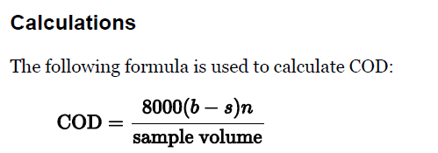

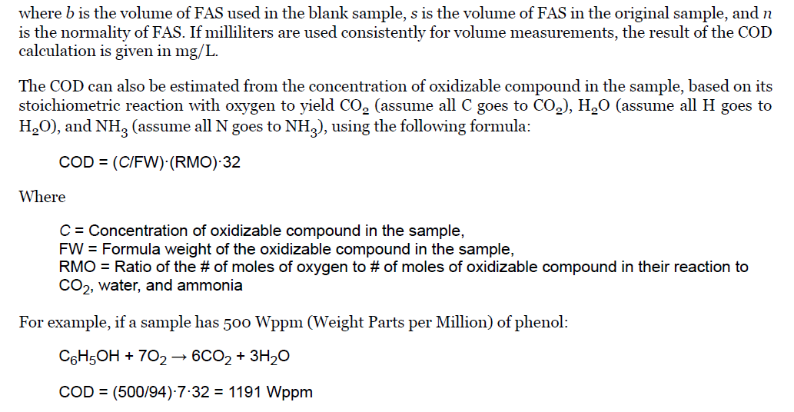
Some samples of water contain high levels of oxidizable inorganic materials which may interfere with the determination of COD. Because of its high concentration in most wastewater, chloride is often the most serious source of interference. Prior to the addition of other reagents, mercuric sulfate can be added to the sample to eliminate chloride interference.

https://www.pharmaguideline.com/2013/06/COD-test-waste-water-organic-pollution-determination.html
COD is used to determine the quantity of pollution in water after wastewater treatment. The higher value of chemical oxygen demand indicates the higher organic pollution in the water sample. Only chemically digest able matter can be determined by the COD test. COD determination takes less duration than the Biological Oxygen Demand test. COD is recommended where the polluted water has toxicity and organic matter can’t be determined by biological oxygen demand and useful in water effluent treatment plants. The organic matter, present in the water sample is oxidized by potassium dichromate in the presence of sulfuric acid, silver sulfate and mercury sulfate to produce carbon dioxide (CO2) and water (H2O). The quantity of potassium dichromate used is calculated by the difference in volumes of ferrous ammonium sulfate consumed in blank and sample titrations. The quantity of potassium dichromate used in the reaction is equivalent to the oxygen (O2) used to oxidize the organic matter of wastewater.
- Take 10 ml of sample into a round bottom reflex flask.
- Add some glass beads to prevent the solution from bumping into the flask while heating.
- Add 1 ml of Mercury sulfate (HgSO4) solution to the flask and mix by swirling the flask.
- Add 5 ml of Potassium dichromate (K2Cr2O7) solution.
- Now add slowly and carefully 15 ml Silver sulfate- Sulfuric acid solution.
- Connect the reflex condenser and digest the content using a hot plate for 2 hours.
- After digestion cools the flask and rinses the condenser with 25 ml of distilled water collecting in the same flask.
- Add 2-4 drops of ferroin indicator to the flask and titrate with 0.025 M ferrous ammonium sulfate solution to the endpoint.
- Make the blank preparation in the same manner as sample using distilled water instead of the sample.

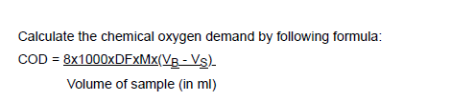
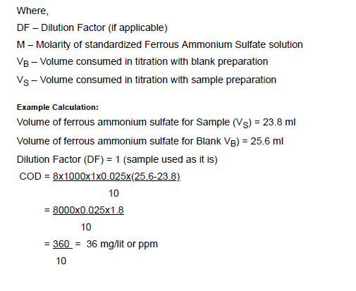
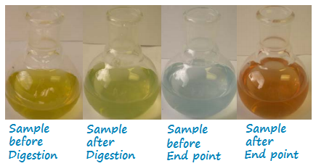
https://images.app.goo.gl/kJ6Hrhkkm5Q6Tict9

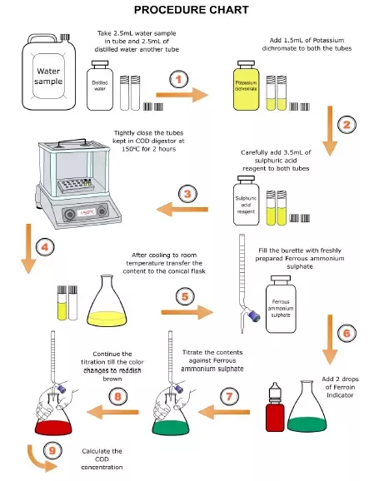
https://images.app.goo.gl/aX8WmYuE6ZR8voXA7
https://www.researchgate.net/profile/Lakna_Panawala/publication/318305894_Difference_Between_BOD_and_COD/links/5b08d33c4585157f87167337/Difference-Between-BOD-and-COD.pdf
https://theconstructor.org/environmental-engg/difference-chemical-oxygen-demand-cod-biological-oxygen-demand-bod/34792/

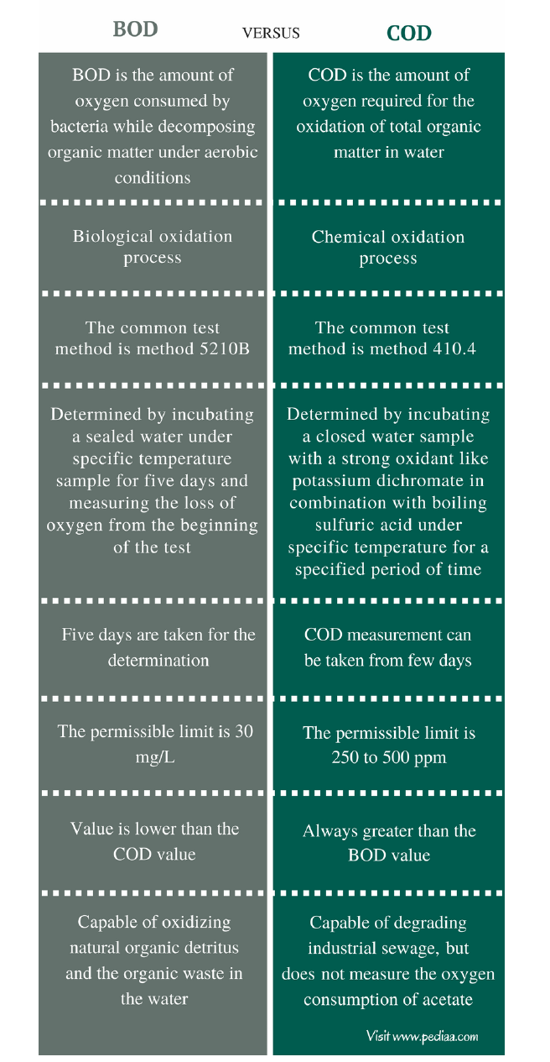
BOD is performed by aerobic organisms | COD is performed by chemical reagents

Total dissolved solids (TDS)
https://water-research.net/index.php/water-treatment/tools/total-dissolved-solids
Dissolved solids" refer to any minerals, salts, metals, cations or anions dissolved in water. Total dissolved solids (TDS) comprise inorganic salts (principally calcium, magnesium, potassium, sodium, bicarbonates, chlorides, and sulfates) and some small amounts of organic matter that are dissolved in water. TDS in drinking-water originate from natural sources, sewage, urban run-off, industrial wastewater, and chemicals used in the water treatment process, and the nature of the piping or hardware used to convey the water, i.e., the plumbing. In certain areas, elevated TDS can be by natural environmental features such as mineral springs, carbonate deposits, salt deposits, and sea water intrusion, but other sources may include: salts used for road de-icing, anti-skid materials, drinking water treatment chemicals, stormwater, and agricultural runoff, and point/non-point wastewater discharges. In general, the TDS concentration is the sum of the cations (positively charged) and anions (negatively charged) ions in the water. Therefore, the total dissolved solids test provides a qualitative measure of the amount of dissolved ions but does not tell us the nature or ion relationships. In addition, the test does not provide us insight into the specific water quality issues, such as Elevated Hardness, Salty Taste, or Corrosiveness. Therefore, the total dissolved solids test is used as an indicator test to determine the general quality of the water. The sources of total dissolved solids can include all of the dissolved cations and anions, but the following table can be used as a generalization of the relationship of TDS to water quality problems.
Cations combined with Carbonates  CaCO3, MgCO3 etc | Associated with hardness, scale formation, bitter taste
Cations combined with Chloride  NaCl, KCl | Salty or brackish taste, increase corrosivity
An elevated total dissolved solids (TDS) concentration is not a health hazard. The TDS concentration is a secondary drinking water standard and, therefore, is regulated because it is more of an aesthetic rather than a health hazard. An elevated TDS indicates the following:
- The concentration of the dissolved ions may cause the water to be corrosive, salty or brackish taste, result in scale formation, and interfere and decrease efficiency of hot water heaters; and
- Many contain elevated levels of ions that are above the Primary or Secondary Drinking Water Standards, such as an elevated level of nitrate, arsenic, aluminum, copper, lead, etc.
In a laboratory setting, the total dissolved solids is determined by filtering a measured volume of sample through a standard glass fiber filter. The filtrate (i.e., filtered liquid) is then added to a preweighed ceramic dish that is placed in a drying oven at a temperature of 103 C. After the sample dries, the temperature is increased to 180 C to remove an occluded water, i.e., water molecules trapped in mineral matrix. Total dissolved solids means the total dissolved (filterable) solids as determined by use of the method specified in Title 40 of the Code of Federal Regulations (40 CFR) Part 136. High total dissolved solids may affect the aesthetic quality of the water, interfere with washing clothes and corroding plumbing fixtures. For aesthetic reasons, a limit of 500 mg/l (milligrams per liter) has been established as part of the Secondary Drinking Water Standards.
- Filter water sample frm a rinsed and dried glass fiber filter. Collect the filtrate (liquid) and rinse water in a flask. The minimum sample volume should be 100 ml and should use at least 3 rinses of 20 to 30 ml volumes. (Recording your data)- Record weight of container and volume of filtrate - do not include the volume of the rinse water). The rinse water should be deionized water. Do not touch container with bare hands.
- Transfer the filtrate to a ceramic or glass Pyrex container. The container should be weighed to the nearest 0.0000 g and place the container in the drying oven, which is set at 103 C. Add the filtrate to the container and allow the sample to stay in the oven at 103 C for 24 hours. If possible, increase the temperature of the drying oven to 180 C and allow the sample to dry for up to 8 hours. Remove the container – but it is hot. After removing from the drying oven, the sample should be placed in a desiccator to cool in a dry air environment for at least 3 to 4 hours. If the sample cooled in a moist environment, the sample would increase in weight because of the addition of water vapor from the air. Remember the sample is very hot and can melt plastic. Do not touch container with bare hands.
- After the container cools, reweigh the container at least three times to the nearest 0.0000 g (Recording your data)
- Subtract the initial weight (in grams) of the empty container from the weight of the container with the dried residue to obtain the increase in weight. Then do the following:
A- Weight of clean dried container (0.0000 grams)
B- Weight of container and residue (0.0000 grams)
C- Volume of Sample (do not include rinse water ) (100 ml)
Concentration (mg/L) = ((B - A)/ C)* (1000 mg/g) * (1000 ml/L)
Example
A= 100.0001 g
B = 100.0020 g
C = 100 ml
Concentration (mg/L) = ((100.0220 - 100.0001)/ 100) * 1000 * 1000 = 219 mg/L

Moreover, the tds concentration can be related to the conductivity of the water, but the relationship is not a constant. The relationship between total dissolved solids and conductivity is a function of the type and nature of the dissolved cations and anions in the water and possible the nature of any suspended materials. For example, a NaCl solution and KCl solution with a conductivity of 10000 umhos/cm will not have the sample concentration of NaCl or KCl and they will have different total dissolved solids concentration. Conductivity is measured through the use of a meter and is usually about 100 times the total cations or anions expressed as equivalents and the total dissolved solids (TDS) in ppm usually ranges from 0.5 to 1.0 times the electrical conductivity. Total Dissolved Solids can be measured in the field using an electronic pen. Many of these devices actually measure the conductivity of the water, i.e., the ability of the water to carry a charge, and not the actual total dissolved solids. These devices then calculate the total dissolved solids assuming that the primary dissolved minerals are either a combination of NaCl or KCl. Therefore, the measurement of total dissolved solids by these devices are not an accurate measure, but an approximation.
https://en.wikipedia.org/wiki/Total_dissolved_solids
Total dissolved solids (TDS) is a measure of the dissolved combined content of all inorganic and organic substances present in a liquid in molecular, ionized, or micro-granular (colloidal sol) suspended form. TDS is sometimes referred to as parts per million (ppm). You can test water quality levels using a digital TDS PPM meter. Generally, the operational definition is that the solids must be small enough to survive filtration frm a filter with 2-micrometer (nominal size, or smaller) pores. Total dissolved solids are normally discussed only for freshwater systems, as salinity includes some of the ions constituting the definition of TDS. The principal application of TDS is in the study of water quality for streams, rivers, and lakes. Although TDS is not generally considered a primary pollutant (e.g. it is not deemed to be associated with health effects), it is used as an indication of aesthetic characteristics of drinking water and as an aggregate indicator of the presence of a broad array of chemical contaminants. Primary sources for TDS in receiving waters are agricultural runoff and residential (urban) runoff, clay-rich mountain waters, leaching of soil contamination, and point source water pollution discharge from industrial or sewage treatment plants. The most common chemical constituents are calcium, phosphates, nitrates, sodium, potassium, and chloride, which are found in nutrient runoff, general stormwater runoff and runoff from snowy climates where road de-icing salts are applied. The chemicals may be cations, anions, molecules or agglomerations on the order of one thousand or fewer molecules, so long as a soluble micro-granule is formed. More exotic and harmful elements of TDS are pesticides arising from surface runoff. Certain naturally occurring total dissolved solids arise from the weathering and dissolution of rocks and soils. The United States has established a secondary water quality standard of 500 mg/l to provide for palatability of drinking water. Total dissolved solids are differentiated from total suspended solids (TSS), in that the latter cannot pass through a sieve of 2 micrometers and yet are indefinitely suspended in solution. The term settleable solids refers to material of any size that will not remain suspended or dissolved in a holding tank not subject to motion, and excludes both TDS and TSS. Settleable solids may include larger particulate matter or insoluble molecules. Water can be classified by the level of total dissolved solids (TDS) in the water:
Fresh water: TDS is less than 1,000 mg/L
Brackish water: TDS = 1,000 to 10,000 mg/L
Saline water: TDS = 10,000 to 35,000 mg/L
Hypersaline: TDS greater than 35,000 mg/L
Drinking water generally has a TDS below 500 mg/L. Higher TDS Fresh Water is drinkable but taste may be objectionable.
Measurement
The two principal methods of measuring total dissolved solids are gravimetric analysis and conductivity. Gravimetric methods are the most accurate and involve evaporating the liquid solvent and measuring the mass of residues left. This method is generally the best, although it takes lot of duration. If inorganic salts comprise the great majority of TDS, gravimetric methods are appropriate.
Electrical conductivity of water is directly related to the concentration of dissolved ionized solids in the water. Ions from the dissolved solids in water create the ability for that water to conduct an electric current, which can be measured using a conventional conductivity meter or TDS meter. When correlated with laboratory TDS measurements, conductivity provides an approximate value for the TDS concentration, usually to within ten-percent accuracy. The relationship of TDS and specific conductance of groundwater can be approximated by the following equation:
TDS = keEC
where TDS is expressed in mg/L and EC is the electrical conductivity in microsiemens per centimeter at 25 °C. The correlation factor ke varies between 0.55 and 0.8.
Total organic carbon (TOC)
https://en.wikipedia.org/wiki/Total_organic_carbon
https://www.lar.com/products/toc-analysis/toc-total-organic-carbon.html
Total organic carbon (TOC) is the amount of carbon found in an organic compound and is often used as a non-specific indicator of water quality or cleanliness of pharmaceutical manufacturing equipment. TOC may also refer to the amount of organic carbon in soil, or in a geological formation, particularly the source rock for a petroleum play; 2% is a rough minimum. For marine surface sediments average TOC content is 0.5% in the deep ocean, and 2% along the eastern margins. A typical analysis for total carbon (TC) measures both the total organic carbon (TOC) present and the complementing total inorganic carbon (TIC), the latter representing the amount of non-organic caron, like carbon in carbonate minerals. Subtracting the inorganic carbon from the total carbon yields TOC. Another common variant of TOC analysis involves removing the TIC portion first and then measuring the leftover carbon. This method involves purging an acidified sample with carbon-free air or nitrogen prior to measurement, and so is more accurately called non-purgeable organic carbon (NPOC)
The TOC in water also indicates of the organic contamination. As the name of the parameter already suggests, it is supposed to and has to detect the total organic carbon of the sample. Therefore, the inorganic carbon, literally carbon dioxide dissolved in water and its dissolved ions, have to be excluded from the sample.
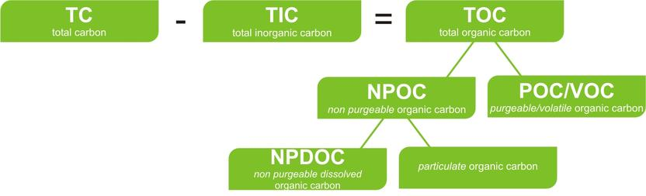

Generally, the determination of TOC is done by thermal or wet chemical oxidation, so that CO2 is formed, which is subsequently measured by a NDIR detector. TOC measurements are well suited for online measurements since its provides fast and meaningful results depending on the function of the process analyser. The TOC takes a special position in well-known regulatories.
TOC has been an analytic technique used to measure water quality during the drinking water purification process. TOC in source waters comes from decaying natural organic matter (NOM) as well as synthetic sources. Humic acid, fulvic acid, amines, and urea are examples of NOM. Some detergents, pesticides, fertilizers, herbicides, industrial chemicals, and chlorinated organics are examples of synthetic sources. Before source water is treated for disinfection, TOC provides an estimate of the amount of NOM in the water source. In water treatment facilities, source water is subject to reaction with chloride containing disinfectants. When the raw water is chlorinated, active chlorine compounds (Cl2, HOCl, ClO−) react with NOM to produce chlorinated disinfection byproducts (DBPs). Introduction of organic matter into water systems occurs not only from living organisms and from decaying matter in source water, but also from purification and distribution system materials. A relationship may exist between endotoxins, microbial growth, and the development of biofilms on pipeline walls and biofilm growth within pharmaceutical distribution systems. A correlation is believed to exist between TOC concentrations and the levels of endotoxins and microbes.
Measurement
A variety of different terms are used to identify the different types of carbon present at different levels of detail.
Total Carbon (TC) – all the carbon in the sample, including both inorganic and organic carbon
Total Inorganic Carbon (TIC) – often referred to as inorganic carbon (IC), carbonate, bicarbonate, and dissolved carbon dioxide (CO2).
Total Organic Carbon (TOC) – material derived from decaying vegetation, bacterial growth, and metabolic activities of living organisms or chemicals.
Elemental Carbon (EC) – charcoal, coal, and soot. Resistant to analytical digestion and extraction, EC can be a fraction of either TIC or TOC depending on analytical approach.[9]
Non-Purgeable Organic Carbon (NPOC) – commonly referred to as TOC; organic carbon remaining in an acidified sample after purging the sample with gas.
Purgeable (volatile) Organic Compound (VOC) – organic carbon that has been removed from a neutral, or acidified sample by purging with an inert gas. These are the same compounds referred to as Volatile Organic Compounds (VOC) and usually determined by Purge and Trap Gas Chromatography.
Dissolved Organic Carbon (DOC) – organic carbon remaining in a sample after filtering the sample, typically using a 0.45 micrometer filter.
Suspended Organic Carbon – also called particulate organic carbon (POC); the carbon in particulate form that is too large to pass through a filter.
Since all TOC analyzers only actually measure total carbon, TOC analysis always requires some accounting for the inorganic carbon that is always present. One analysis technique involves a two-stage process commonly referred to as TC-IC. It measures the amount of inorganic carbon (IC) evolved from an acidified aliquot of a sample and also the amount of total carbon (TC) present in the sample. TOC is calculated by subtraction of the IC value from the TC the sample. Another variant employs acidification of the sample to evolve carbon dioxide and measuring it as inorganic carbon (IC), then oxidizing and measuring the remaining non-purgeable organic carbon (NPOC). This is called TIC-NPOC analysis. A more common method directly measures TOC in the sample by again acidifying the sample to a pH value of two or less to release the IC gas but in this case to the air not for measurement. The remaining non-purgeable CO2 gas (NPOC) contained in the liquid aliquot is then oxidized releasing the gases. These gases are then sent to the detector for measurement. Whether the analysis of TOC is by TC-IC or NPOC methods, it may be broken into three main stages: Acidification, Oxidation, Detection and Quantification.
The stage 1 is acidification of the sample for the removal of the IC and POC gases. The release of these gases to the detector for measurement or to the air is dependent upon which type of analysis is of interest, the former for TC-IC and the latter for TOC (NPOC).

Acidification- Addition of acid and inert-gas sparging allows all bicarbonate and carbonate ions to be converted to carbon dioxide, and this IC product vented along with any POC that was present.
Oxidation- The second stage is the oxidation of the carbon in the remaining sample in the form of carbon dioxide (CO2) and other gases. Modern TOC analyzers perform this oxidation step by several processes: High Temperature Combustion, High temperature catalytic oxidation (HTCO), Photo-oxidation alone, Thermo-chemical oxidation, Photo-chemical oxidation, Electrolytic Oxidation,
High temperature combustion- Prepared samples are combusted at 1,200 °C in an oxygen-rich atmosphere. All carbon present converts to carbon dioxide, flows through scrubber tubes to remove interferences such as chlorine gas, and water vapor, and the carbon dioxide is measured either by absorption into a strong base then weighed, or using an Infrared Detector. Most modern analyzers use non-dispersive infrared (NDIR) for detection of the carbon dioxide. Compared to the conventional high temperature catalytic oxidation, the great benefit of the combustion-method is the high oxidation power, so that oxidation-promoting catalysts are superfluous.
High temperature catalytic oxidation- A manual or automated process injects the sample onto a platinum catalyst at 680 °C in an oxygen rich atmosphere. The concentration of carbon dioxide generated is measured with a non-dispersive infrared (NDIR) detector. Oxidation of the sample is complete after injection into the furnace, turning oxidizable material in the sample into gaseous form. A carbon-free carrier gas transports the CO2, through a moisture trap and halide scrubbers to remove water vapor and halides from the gas stream before it reaches the detector. These substances can interfere with the detection of the CO2 gas. The HTCO method may be useful in those applications where difficult to oxidize compounds, or high molecular weight organics, are present as it provides almost complete oxidation of organics including solids and particulates small enough to be injected into the furnace. The major drawback of HTCO analysis is its unstable baseline resulting from the gradual accumulation of non-volatile residues within the combustion tube. These residues continuously change TOC background levels requiring continuous background correction. Because aqueous samples are injected directly into a very hot, usually quartz, furnace only small aliquots (less than 2 milliliters and usually less than 400 micro-liters) of sample can be handled making the methods less sensitive than chemical oxidation methods capable of digesting as much as 10 times more sample. Also, the salt content of the samples do not combust, and so therefore, gradually build a residue inside the combustion tube eventually clogging the catalyst resulting in poor peak shapes, and degraded accuracy or precision, unless appropriate maintenance procedures are followed. The catalyst should be regenerated or replaced as needed. To avoid this problem the manufacturing industry has developed several concepts, such as matrix separation, ceramic reactors, better process control or methods without catalysts.
Photo-oxidation (ultraviolet light)- In this oxidation scheme, ultra-violet light alone oxidizes the carbon within the sample to produce CO2. The UV oxidation method offers the most reliable, low maintenance method of analyzing TOC in ultra-pure waters.
Ultraviolet/persulfate oxidation- As he photo-oxidation method, UV light is the oxidizer but the oxidation power of the reaction is magnified by the addition of a chemical oxidizer, which is usually a persulfate compound. Free radical oxidants formed. The UV–chemical oxidation method offers a relatively low maintenance, high sensitivity method for a wide range of applications. However, there are oxidation limitations of this method. Limitations include the inaccuracies associated with the addition of any foreign substance into the analyte and samples with high amounts of particulates. Performing "System Blank" analysis, which is to analyze then subtract the amount of carbon contributed by the chemical additive, inaccuracies are lowered. However, analyses of levels below 200 ppb TOC are still difficult.
Thermochemical persulfate oxidation- Also known as heated persulfate, the method utilizes the same free radical formation as UV persulfate oxidation except uses heat to magnify the oxidizing power of persulfate. Chemical oxidation of carbon with a strong oxidizer, such as persulfate, is highly efficient, and unlike UV, is not susceptible to lower recoveries caused by turbidity in samples. The analysis of system blanks, necessary in all chemical procedures, is especially necessary with heated persulfate TOC methods because the method is so sensitive that reagents cannot be prepared with carbon contents low enough to not be detected. Persulfate methods are used in the analysis of wastewater, drinking water, and pharmaceutical waters. When used in conjunction with sensitive NDIR detectors heated persulfate TOC instruments readily measure TOC at single digit parts per billion (ppb) up to hundreds of parts per million (ppm) depending on sample volumes.
Detection and quantification
Accurate detection and quantification are the most vital components of the TOC analysis process. Conductivity and non-dispersive infrared (NDIR) are the two common detection methods used in modern TOC analyzers.
Conductivity
There are two types of conductivity detectors, direct and membrane. Direct conductivity provides an all-encompassing approach of measuring CO2. This detection method uses no carrier gas, is good at the parts per billion (ppb) ranges, but has a very limited analytical range. Membrane conductivity relies upon the filtering of the CO2 prior to measuring it with a conductivity cell. Both methods analyze sample conductivity before and after oxidization, attributing this differential measurement to the TOC of the sample. During the sample oxidization phase, CO2 (directly related to the TOC in the sample) and other gases are formed. The dissolved CO2 forms a weak acid, thereby changing the conductivity of the original sample proportionately to the TOC in the sample. Conductivity analyses assume that only CO2 is present within the solution. As long as this holds true, then the TOC calculation by this differential measurement is valid. However, depending on the chemical species present in the sample and their individual products of oxidation, they may present either a positive or a negative interference to the actual TOC value, resulting in analytical error. Some of the interfering chemical species include Cl−, HCO3−, SO32−, SO2−, ClO2−, and H+. Small changes in pH and temperature fluctuations also contribute to inaccuracy. Membrane conductivity analyzers have improved upon the direct conductivity approach by incorporating the use of hydrophobic gas permeation membranes to allow a more “selective” passage of the dissolved CO2 gas and nothing else. This provides a more precise and accurate measurement of the organics that were converted to CO2.
Non-dispersive infrared (NDIR)
The non-dispersive infrared analysis (NDIR) method offers the only practical interference-free method for detecting CO2 in TOC analysis. The principal advantage of using NDIR is that it directly and specifically measures the CO2 generated by oxidation of the organic carbon in the oxidation reactor, rather than relying on a measurement of a secondary, corrected effect, such as used in conductivity measurements. A traditional NDIR detector relies upon flow-through-cell technology, where the oxidation product flows into and out of the detector continuously. A region of absorption of infrared light specific to CO2, usually around 4.26 µm (2350 cm⁻¹), is measured over time as the gas flows through the detector. A second reference measurement that is non-specific to CO2 is also taken and the differential result correlates to the CO2 concentration in the detector at that moment. As the gas continues to flow into and out of the detector cell the sum of the measurements results in a peak that is integrated and correlated to the total CO2 concentration in the sample aliquot.
A new advance of NDIR technology is Static Pressurized Concentration (SPC). The exit valve of the NDIR is closed to allow the detector to become pressurized. Once the gases in the detector have reached equilibrium, the concentration of the CO2 is analyzed. This pressurization of the sample gas stream in the NDIR, a patented technique, allows for increased sensitivity and precision by measuring the entirety of the oxidation products of the sample in one reading, compared to flow-through cell technology. The output signal is proportional to the concentration of CO2 in the carrier gas, from the oxidation of the sample aliquot. UV/ Persulfate oxidation combined with NDIR detection provides good oxidation of organics, low instrument maintenance, good precision at ppb levels, relatively fast sample analysis time and easily accommodates multiple applications, including purified water (PW), water for injection (WFI), CIP, drinking water and ultra-pure water analyses.
Analyzers
Virtually all TOC analyzers measure the CO2 formed when organic carbon is oxidized and/or when inorganic carbon is acidified. Oxidation is performed either through Pt-catalyzed combustion, by heated persulfate, or with a UV/persulfate reactor. Once the CO2 is formed, it is measured by a detector: either a conductivity cell (if the CO2 is aqueous) or a non-dispersive infrared cell (after purging the aqueous CO2 into the gaseous phase). Conductivity detection is only desirable in the lower TOC ranges in deionized waters, whereas NDIR detection excels in all TOC ranges. A variation described as Membrane Conductometric Detection can allow for measurement of TOC across a wide analytical range in both deionized and non-deionized water samples. Modern high-performance TOC instruments are capable of detecting carbon concentrations well below 1 µg/L (1 part per billion or ppb). A total organic carbon analyzer determines the amount of carbon in a water sample. By acidifying the sample and flushing with nitrogen or helium the sample removes inorganic carbon, leaving only organic carbon sources for measurement. There are two types of analyzers. One uses combustion and the other chemical oxidation. This is used as a water purity test, as the presence of bacteria introduces organic carbon.
Analyzer field testing and Reports
A non-profit research and testing organization, the Instrumentation Testing Association (ITA) can provide results of field testing online TOC analyzers in an industrial wastewater application.[17] Gulf Coast Waste Disposal Authority (GCWDA), Bayport Industrial Wastewater Treatment Plant in Pasadena, Texas sponsored and conducted this test in 2011. The GCWDA Bayport facility treats approximately 30 mgd of industrial waste received from approximately 65 customers (primarily petrochemical). Field tests consisted of operating online TOC analyzers at the influent of the Bayport facility in which TOC concentrations can range from 490 to 1020 mg/L with an average of 870 mg/L. GCWDA conducts approximately 102 TOC analyses in their laboratory per day at their Bayport treatment facility and use TOC measurements for process control and billing purposes. GCWDA plans to use online TOC analyzers for process control, detecting influent slug loads from industries and to potentially use online TOC analyzers to detect and monitor volatiles of the incoming stream. Field tests were conducted for a period of 90-days and used laboratory conformance measurements once per day to compare with analyzer output to demonstrate the instrument's overall accuracy when subjected to many simultaneously changing parameters as experienced in real-time monitoring conditions. Field test results can provide information regarding instrument design, operation and maintenance requirements which influence the performance of the instruments in field applications. The field test report includes evaluations of online TOC analyzers utilizing the following technologies: High Temperature Combustion (HTC), High Temperature Catalytic/Combustion Oxidation (HTCO), Supercritical Water Oxidation (SCWO), and Two-Stage Advanced Oxidation (TSAO).
Combustion
In a combustion analyzer, half of the sample is injected into a chamber where it is acidified, usually with phosphoric acid, to turn all of the inorganic carbon into carbon dioxide as per the following reaction:
CO2 + H2O ⇌ H2CO3 ⇌H+ + HCO3− ⇌ 2H+ + CO32−
This is then sent to a detector for measurement. The other half of the sample is injected into a combustion chamber which is raised to between 600–700 °C, some even up to 1200 °C. Here, all the carbon reacts with oxygen, forming carbon dioxide. It's then flushed into a cooling chamber, and finally into the detector. Usually, the detector used is a non-dispersive infrared spectrophotometer. By finding the total inorganic carbon and subtracting it from the total carbon content, the amount of organic carbon is determined.
Chemical oxidation
Chemical oxidation analyzers inject the sample into a chamber with phosphoric acid followed by persulfate. The analysis is separated into two steps. One removes inorganic carbon by acidification and purging. After removal of inorganic carbon persulfate is added and the sample is either heated or bombarded with UV light from a mercury vapor lamp. Free radicals form persulfate and react with any carbon available to form carbon dioxide. The carbon from both determination (steps) is either run through membranes which measure the conductivity changes that result from the presence of varying amounts of carbon dioxide, or purged into and detected by a sensitive NDIR detector. Same as the combustion analyzer, the total carbon formed minus the inorganic carbon gives a good estimate of the total organic carbon in the sample. This method is often used in online applications because of its low maintenance requirements.
Applications
TOC is the initial chemical analysis to be carried out on potential petroleum source rock in oil exploration. It is very important in detecting contaminants in drinking water, cooling water, water used in semiconductor manufacturing, and water for pharmaceutical use. Analysis may be made either as an online continuous measurement or a lab-based measurement. TOC detection is an important measurement because of the effects it may have on the environment, human health, and manufacturing processes. TOC is a highly sensitive, non-specific measurement of all organics present in a sample. It, therefore, can be used to regulate the organic chemical discharge to the environment in a manufacturing plant. In addition, low TOC can confirm the absence of potentially harmful organic chemicals in water used to manufacture pharmaceutical products. TOC is also of interest in the field of potable water purification due to byproducts of disinfection. Inorganic carbon poses little to no threat.

